February 2006

THe Official Publication of ALOA—An International Association of Security Professionals

1 ■*  1 11111

[www.aloa.org](http://www.aloa.org)

LOCKS

Check out the latest

locks being in into the market.

*m*

PLUS!

Greg Perry tackles the Cannon Gun Safe  
Security in Vour Own Backyard  
Locksmith to Forensic Locksmith  
and More!

*********AUTO**SCH 3-DIGIT 303 Breck H. Camp CML PO Box 47070 Atlanta GA 30362-0070

liillilliiiiilliilliiiilillliiilliiiliiillliiiliiil

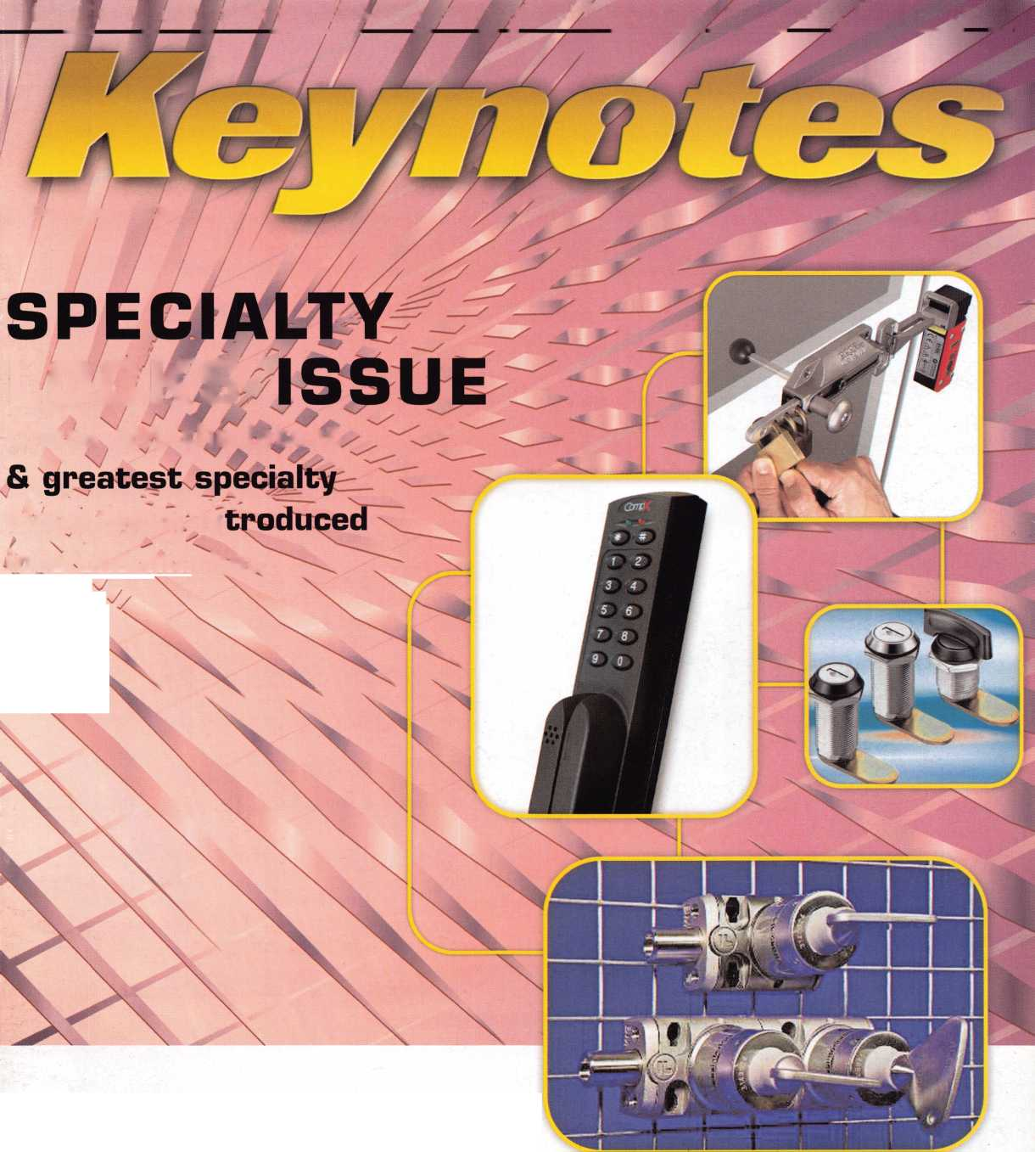

**OUR STAND**

**You’re in good hands.**

«**»*";

Subject to availability and qualify itions. Allstate Company, Bridgewater, N.J-The "' :>ped Hands" 1<

isurance Compant^^n\flst” n indemnity Company, Northbrook, II,. Allstate County Mutual insurance Company, Irving, I X, Allstate New .Jersey Insurance  
jo .iO#JW'Fod M-rvif.c mark and 'Our Stand" is a service mark of Allstate Insurance Company. @2005 Allstate Insurance Company, Northbrook, It.

IT’S QUITE POSSIBLY YOUR MOST

**TRUSTED SIDEKI**

**Keep it in Good Hands® with Allstate.**

As a small business owner, there are few things you quick certificates of insurance,

rely on more than your vehicle to keep you going. with the claims process, and more.

Your local Allstate agent can help protect it and the most widely recognized names

your small business with services you need including Are you in Good Hands®?

the business.

1-800-859-0247

CALL NOW TO LOCATE YOUR NEARBY ALLSTATE AGENT.

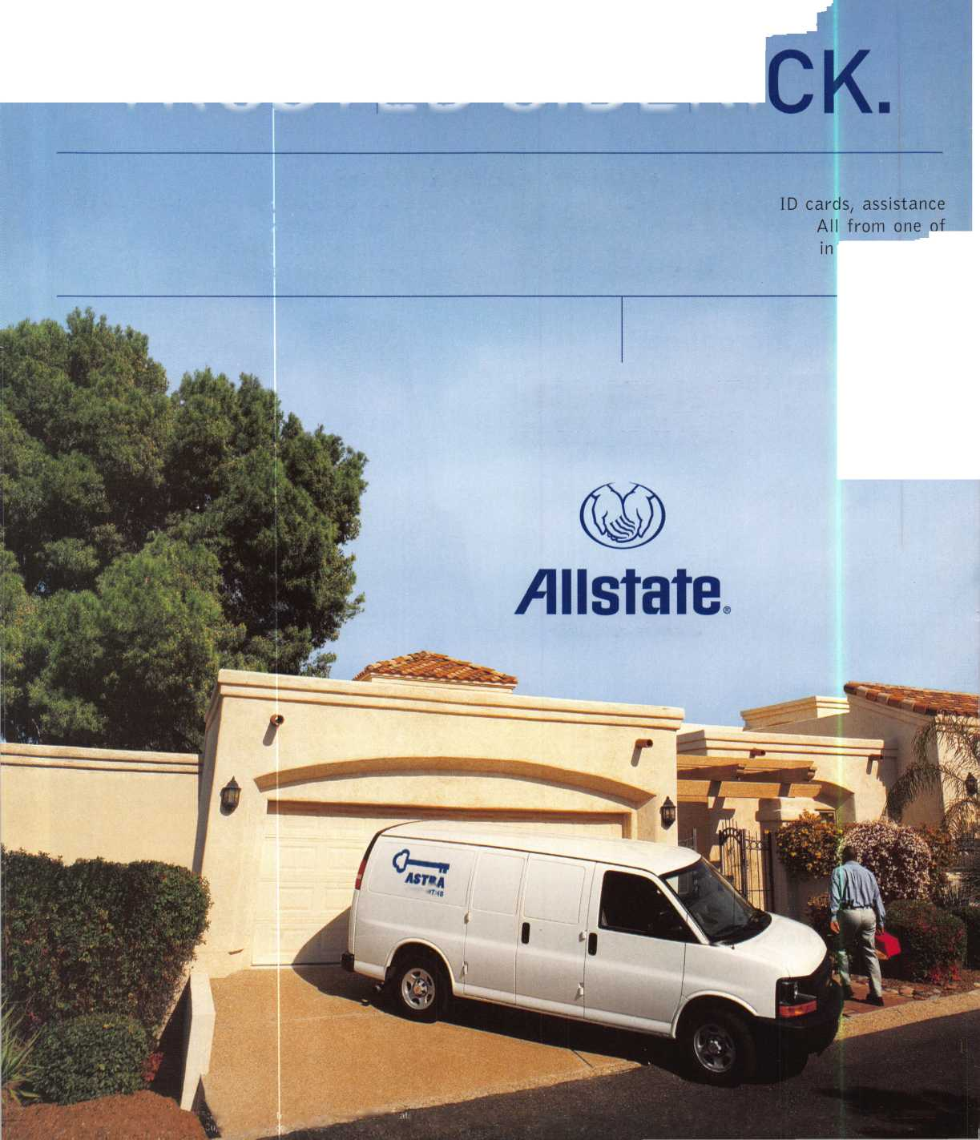

A Name You Know

As a business owner, you know the importance of a good name. Your name is your reputation. Your name stands for all that you offer in products and services. It’s a symbol of who you are. So, we thought you might like to know that Allstate, the name you know for insuring your personal vehicle and your home, also offers a business auto policy to help protect vehi­cles used in your locksmith business.

The following are coverages typically included in our business auto policy that might be important to you as a business owner:

Business Auto Liability coverage

* Higher limits up to $2,000,000 per occur­rence.
* Protects you if you are legally responsible for injuries and damages arising out of the ownership, maintenance, or use of business vehicles.
* Cost is based on several factors, including garage location, type and use of vehicle, and the violation and accident activity of your drivers.
* Additional Insured coverage may be required when you contract with govern­mental agencies or bid on local commercial jobs.
* Generally not available on a personal auto policy.
* Usually is no charge to add an insured to a Commercial Auto policy.

Hired Auto coverage

* Provides liability coverage for those vehicles you rent, hire or borrow for business use.
* The premium for hired auto liability coverage is based on the estimated annual rental cost.
* Tools and Special Equipment
* Provides protection to permanently attached equipment on your vehicle.
* You will need to let your agent know the value of the equipment to include in the cost of the vehicle.

You're good at your business. Your insurance com­pany should be the same way.

Contact an Allstate agent to discuss your business auto insurance needs. To be referred to an agent, please call 800.859.0247 or email

[abisO@allstate.com](mailto:abisO@allstate.com).

Subject to availability and qualifications. Insurance coverage is subject to policy terms.

Allstate Insurance Company

Allstate Indemnity Company Northbrook, IL

Allstate County Mutual Insurance Company Irving, TX

Allstate New Jersey Insurance Company Bridgewater, NJ

allstate.com

© 2005 Allstate Insurance Company, Northbrook, IL

Get Whats  
Coming To You

ALOA continues to provide you with this and other great benefits and services!

Q V

UJeJL2J

UULUdj

CpdbCD

c5oo

Need information in a hurry?

Use ALOA’s Fax On Demand service.

Just call 310-575-5074 and receive:

1. ALOA Index of Documents Becoming a Locksmith (Ipg)

Locksmith Career Summary (3pg) Locksmith School List (2pg)

ACE Class Schedule (8pg)

Certification lnformation(3pg)

PRP Category List (Ipg)

ALOA Membership Application(2pg) ALOA List of Benefits (Ipg)

. Scholarship Application Form (Ipg)

. ALOA Video Library Order Form (Ipg)

. ALOA Membership Items Order Form (Ipg)

113. Safe & Vault Technicians Association Member Application/Subscription Form (2pg)

. ALOA Chapter Roster (3pg)

. Legislative Action Network (2pg)

. Legislative Action Network Newsletters (Ipg)

. Various State Laws (lOpg)

. Industry Position Pager (Ipg)

. Current Legislative Action Network Newsletters (Ipg)

120. Board of Directors Nomination Form (2pg)

. ALOA Convention Registration . ALOA Board Expense Reimbursement & Request Form

310**-**575-5074

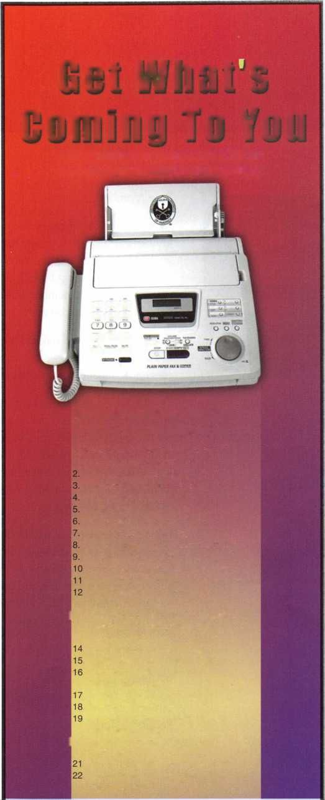

presidential

viewpoint

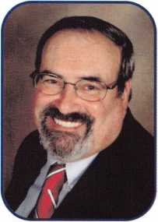

Dear Members,

At the end of December a man, who I was lucky enough to know, passed away. His name was  
Jay Nelson. Jay never sought the limelight, though he was one of the most knowledgeable lock-  
smiths I have ever had the pleasure of meeting. The last time I spoke to Jay, he was in search of  
some information about a lock company in England. He was a lock collector, par excellence. His  
ALOA membership number was 7. If I am fortunate enough to find myself at the pearly gates at  
the end of my tenure on earth, I am sure I will see Jay, working on the lock.

You all know that old axiom-Time moves quicker as you get older. I don't know if that applies to  
associations, but here we are in the second month of our fiftieth year. In a blink of an eye it will be  
convention time! But let's back up a minute and put on the brakes.

The SAVTA Convention is starting at the end of this month in Albuquerque, New Mexico. Your  
Board of Directors and I will be there. Along with our Spring Board meeting agenda, we will also  
be attending the convention. So, if you have a compliment, a gripe, or even a question, SAFETECH  
2006 would be a perfect time to contact your local director to be heard or get that question  
answered. Well all be on the convention floor; come over and talk to us. Also, if you will still be  
at the convention on Sunday, March 5th, you are welcomed to come and see the Board at work  
at their Spring Meeting.

February is a month of holidays-Lincoln's and Washington's birthdays, Groundhog Day and my personal favorite St. Valentine's Day. Speaking of Valentine's Day, how's this for a romantic thought, you and your honey riding with the top down in the ALOA '56 T-Bird. It could be you. Remember, you have to be a member and attend our Fiftieth Anniversary Convention this year in Las Vegas to make this Valentine's Day dream come true.

Take 'er easy!

Sincerely,

Robert E. Mock



Keynotes • February 2006

**MONARCH**

m

**CAL-ROYAL**

**jacbon**

2S

**SARGENT**

**SCHLAGE**

**VON DUPRIN**

**WEISER LOCK**

*AUTOMOTIVE Jet *

**£ DM AMO Ml looker aft**

*HAT A %rAT„n ^=^MMMe'CardM*

*DETERMINATOR MAJOR (person*

PRO-LOKI

STRATTEC^^ ^ hr^J



**DOR-O-fflATIC hes**

***Why Do  
Locksmiths***

***Everywhere Buy  
Supplies at  
H.L.Fiake?***

*\**

*\**

*\**

*\**

*\**

*

*

*Extremely Competitive  
E/Z Free Freight Minimums  
Same Day Shipping*

*Service with a Smile  
High Fill Rate  
Hard to Find Items*

*E/Z Order Web Site*

*[WWW.HlFlAKE.com](http://WWW.HlFlAKE.com)*

* ***Order 24 hours a day***
* ***Updated Every Business Day***
* ***Extra Discount for Web Orders***
* ***Personalized Inventory Lists***

***LOG ON TO..***

[WWW.HLFLAKE](http://WWW.HLFLAKE). COm

*a&Qs

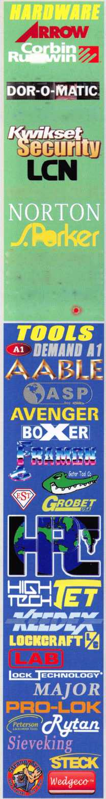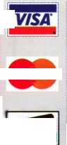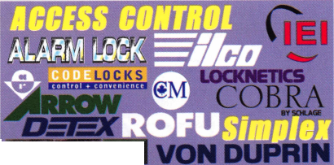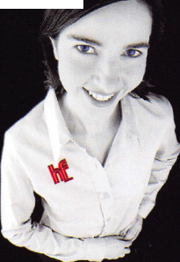

u

r

e

s

feat

SPECIALTY LOCKS 2006



Specialty Locks

Many specially locks are featured in this issue. Find out what these new specialty locks have to offer you.

Cannon Gun Safe

Greg Perry learns that if at first you don't succeed... try something different.

by Greg Perry, CML, CPS



Security in Your Own Backyard

Small businesses are targets in over half the commercial burglaries commited in the U.S. Learn how to protect yourself and your investment.

by Claire L Cohen, CML



From Locksmith to Forensic Locksmith

It takes a special kind of Locksmith to become a Forensic Locksmith. Find out if you fit the bill.

by Daniel E. Cunningham, JD, CRL, CFL, CFATE



Starting Over

Find out how you can help your fellow ALOA member survivors of Hurricanes Rita and Katrina.

|  |  |  |  |
| --- | --- | --- | --- |
| r |  |  |  |
| AD INDEX | |  |  |
| Allstate | Inside Front Cover | |  |
| Fax on Demand |  | 1 |  |
| HL Flake |  | 3 |  |
| Safetech 2006 |  | 7 |  |
| IR |  | 13 |  |
| Service Magic |  | 15 |  |
| ALOA 2006 |  | 19 |  |
| Doorking |  | 21 |  |
| A&B Safe |  | 23 |  |
| CCL |  | 25 |  |
| Strattec |  | 31 |  |
| SafeData |  | 34 |  |
| FKI |  | 35 |  |
| A&B Safe |  | 42 |  |
| PBP |  | 42 |  |
| Payment Retriever |  | 42 |  |
| Turn 10 |  | 42 |  |
| ALOA Bookstore |  | 43 |  |
| MLANJ |  | 44 |  |
| CompX | Inside Back Cover | |  |
| FKI |  | Back Cover |  |
| L |  |  | A |

**Departm nts**

Presidential Viewpoint 2

Execi

App

utive

icants

5

6

|  |  |  |  |
| --- | --- | --- | --- |
| Calendar | 8 | Classified | 36 |
| Core | 9 | Associate Members | 38 |

Legislative 40

Visit our NEW website at [www.aloa.org](http://www.aloa.org)

executive

Volume 52, Issue 2

Additional contact information for the ALOA Board and most Keynotes authors is  
available through "Locksmith Search'" on the ALOA Web site- [www.aloa.org](http://www.aloa.org) or by  
contacting the ALOA office at 3500 Easy Street; Dallas, TX 75247; (800)532-2562;

FAX (214)819-9736; e-mail [aloa@aloa.org](mailto:aloa@aloa.org).

Editor

Betty Henderson [betty@aloa.org](mailto:betty@aloa.org)

Advertising Sales

Kim Hammond voice: 817-645-6778

Fax: 817-645-7599 e-mail: [adsales@aloa.org](mailto:adsales@aloa.org)

Executive Director

Charles W. Gibson, Jr., CAE [charlie@aloa.org](mailto:charlie@aloa.org)

Associate Executive Director

David Lowell, CML, CMST [david@aloa.org](mailto:david@aloa.org)

Convention & Meetings Manager

Jo Anne Mims [joanne@aloa.org](mailto:joanne@aloa.org)

Operations/Membership Manager

Mary May [mary@aloa.org](mailto:mary@aloa.org)

Director of Creative Services

Betty Henderson [betty@aloa.org](mailto:betty@aloa.org)

IT Operations Manager

Greg Jackson [greg@aloa.org](mailto:greg@aloa.org)

Comptroller Kathy J. Romo

Membership Coordinator Shelly Jett

Convention & Meetings Assistant Karen Lyons

PRP/Education Coordinator Mayra Ocon

Mail Room Coordinator Kevin Wesley

Creative Media Specialist Margarita Garza

Accounting Coordinator Joyce Nixon

Executive Assistant Sue Langford

Assistant Education Manager Bob Stafford

Legislation Manager Tim McMullen

Receptionist Shelley Molton

Contributors

Jerome Andrews, CML  
Paul Chandler, CRL  
Claire Cohen, CML  
Brian Costley, CML, CMST  
Eric Costley, CRL

Ray D'Adamo, CML Billy Edwards, CML Dan Graffeo, CRL,CMST Jim Hancock, CPL Jeff Nunberg, CML, CMST

Randy Simpson, CML, CPP Robert Stafford, CML Dave Thielen, CML Greg Perry, CML,CPS

Tom Seroogy

Charles Stephenson, CPS

Dennis Watanabe, CML, CMST

Mission Statement: The Associated Locksmiths of America, Inc. is dedicated to enhancing the professionalism, education and ethics among  
locksmiths and those in related sectors of the physical security industry. With approximately 10,000 members in the United States, Canada and the  
freeworld, ALOA is poised to help members obtain the knowledge, the strength, and the confidence to perform their role in the physical security field  
with pride and dignity. But it is only through active involvement and participation that ALOA can fully achieve its potential—and can help members to  
achieve theirs.

Policies: **Keynotes**® is the official publication of the Associated Locksmiths of America, Inc. (ALOA). **Keynotes**® acts as a moderator without approving,  
disapproving, or guaranteeing the validity or accuracy of any data, claim, or opinion appearing under a byline or obtained or quoted from an acknowl-  
edged source. The opinions expressed by the authors do not necessarily reflect the official views of ALOA. Also, appearance of advertisements and  
new products or service information does not constitute an endorsement of products or services featured by the Association. The Association does not  
accept responsibility for the inaccuracy of any data, claim, or opinion appearing in this publication, due to typographical errors on the part of the  
authors, Association staff or its agents.

Editor's Note: This publication is designed to provide accurate and authoritative information in regard to the subject matter covered. It is provided  
and disseminated with the understanding that the publisher is not engaged in rendering legal or other professional services. If legal advice and other  
expert assistance is required, the services of a competent professional should be sought.

Authors' Payment: Payment for eligible submissions to Keynotes will be based on the following criteria: topic, time spent and past contributions. Authors who  
regularly submit to **Keynotes®** are generally paid a higher rate. The latter is especially true of authors who write to fit specific editorial needs and submit said copy  
by **Keynotes**® deadlines. As a general guideline: Average payment for a 750 word, business or 'light' technical article would be $200. Payment for a 1500 word  
article involving significantly higher time and research efforts would be $400.

Payment will not be offered for articles submitted by ALOA employees or members of the ALOA Board of Directors (unless material is of a technical  
nature), nor for articles submitted by a company that promote that company's products or services. ALOA reserves the right not to pay for articles sub-  
mitted by an individual(s) that promote a particular company's products or services.

Disclaimer: The Associated Locksmiths of America, Inc., (ALOA), reserves the right to refuse any article for any reason. Additionally, ALOA reserves  
the right to edit, amend or modify any article submitted for publication in order to preserve technical accuracy, clarity, fairness or grammatical cor-  
rectness. ALOA will make the best efforts to notify the author of any changes. The extent of ALOA's liability for any article or information contained  
therein will be a notice of correction or retraction in the next possible issue.

**Keynotes**® (ISSN 0277 0792] is published monthly except for the combined June/July issue by The Associated Locksmiths of America, Inc.,  
3500 Easy St., Dallas, TX 75247-6416. Telephone: (214) 819-9733; FAX (214) 819-9736; e-mail [aloa@aloa.org](mailto:aloa@aloa.org). Subscription rates for  
members—$ 15.00 per year. Periodical class postage paid at Dallas, Texas. POSTMASTER: Send address changes to: Keynotes, 3500 Easy St., Dallas,  
TX 75247-6416. © Copyright 2003, All rights reserved. No part of the contents may be reproduced or reprinted in any form without prior  
written permission of the publisher.

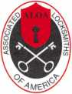

President

Robert Mock (856) 863-0710 [president@aloa.org](mailto:president@aloa.org)

Secretary

John Soderiand, CML, CMST (414) 327-5625 secretary@aloa .org

Directors, Northeast

Peter Sarailian, CRT (201) 944-7547 [nedirector@aloa.org](mailto:nedirector@aloa.org)

Vernon Kelley, CPL

(609)771-3126

[nedirector@aloa.org](mailto:nedirector@aloa.org)

Directors, Southeast

Tom Gillingham. Jr., CML, CPS  
(615) 2640747  
[sedirector@aloa.org](mailto:sedirector@aloa.org)

Ken Kupferman, CML  
(813) 961-5784  
[sedirector@aloa.org](mailto:sedirector@aloa.org)

Director, North Central

William Smith, RL  
(920) 893-5282

Guy Spinello, RL  
(815) 394-1000  
[ncdirector@aioa.org](mailto:ncdirector@aioa.org)

Director, South Central

CD Lipscomb, CML, CPS : (903) 874-3522

[scdirector@aloa.org](mailto:scdirector@aloa.org)

Directors, Southwest

Gordon R. Racine, CML  
(719) 384-4707

[swdirector@aloa.org](mailto:swdirector@aloa.org)

Julie McCluney, CRL  
(714)636-5652  
[swdirector@aloa.org](mailto:swdirector@aloa.org)

Director, Northwest

Jim Jeffries, CPS  
(877) 241-6978  
[nwdirector@aloa.org](mailto:nwdirector@aloa.org)

Director, European

Hans Mejlshede, CML

(453) 539-3939  
[eurdirector@aloa.org](mailto:eurdirector@aloa.org)

Director, Asian

joe j. Lee, CRL  
(215) 289-2404  
[asiandirector@aloa.org](mailto:asiandirector@aloa.org)

Director, Associate

Paul M. justen  
(612) 238-4646  
[asdirector@aloa.org](mailto:asdirector@aloa.org)

Trustees

[trustees@aloa.org](mailto:trustees@aloa.org)

Randy Simpson, CML  
(281) 240-5959

John J. Greenan, CML, CPS  
(773) 486.2030

William Young, CML, CPS  
(610) 647-5042

Past Presidents

2003-2005 William Young, CML, CPS  
2001-2003 Randy Simpson, CML  
1999-2001 John Greenan, CML, CPS  
1997-1999 Dallas C. Brooks  
1995-1997 David Lowell, CML, CMST  
1993-1995 Breck Camp, CML  
1991-1993 Henry Printz, CML  
1989-1991 Evelyn Wersonick, CML, CPS  
1987-1989 Leonard Passarelb, CPL  
1985-1987 Joe Jackman, CML  
1983-1985 Stanley Haney, CPL  
1981-1983 Louis LaGreco, CPL  
1979-1981 John Kerr, RL  
1977-1979 Clifford Cox, CML  
1974-1977 Charles Hetherington  
1972-1974 Gene Laughriage  
1970-1972 William Dutcher, RL  
1968-1970 Constant Maffey, RL  
1966-1968 Harold Edelstein, RL  
1964-1966 William Meacham  
1962-1964 Robert Rackliffe, CPL  
1960-1962 Edwin Toepfer, RL  
1956-1960 Ernest johannesen



Keynotes • February 2006

AE



applicants

for membership

APO

Christopher Jones

Sponsor: Charles E. Batcke CRL, CPS

AL

Birmingham

Edward E. McKenzie

Foley

Clifford R. Dukes

Sponsor: Roy P. Weeks CRL

AZ

Phoenix

Dana T. Hill

Scottsdale

Floyd E. Newman CRL

CA

Norwalk

Janet M. Breese

Sponsor: Jesse J. Hassell RL Palm Springs

Sean M. Cahill

CO

Boulder

Cindy Angell

Sponsor: Thomas R. Johnston

CT

Sandy Hook

Kyle A. Martin

Sponsor: Richard J. Vallinaggi

FL

Boynton Beach

Randy Sofferman

Sponsor: Ray Press

GA

Stockbridge

Edward D. Hanes

Sponsor: John C. Elliott Jr, CML, CPS Woodstock

Joseph C. Grimes

Sponsor: John C. Elliott Jr, CML, CPS

IL

Chicago

Kael Duprey

Sponsor: Kenny R. Carroll

Lexington

Jeff L. Cooper

Sponsor: Harold L. Hardy CRL

AAA

New Bedford

Albert C. Ramos

Sponsor: Paul A. Wesoly RL

Ml

Metamora

Bruce Likowski

Sponsor: Maurice R. Horne CML

MS

NY

New York

Yaron Erez

WA

Auburn

Loren C. Meiser

Sponsor: Jim L. Jeffries CPS

Wl

Beloit

Bradley Smith

Sponsor. MichaelB. SlilwellCRL

TX

Uvalde

Otto E. Arnim

Sponsor. G Don ProbasooCML

VA

Richmond

Todd J. Keilholtz

Yorktown

Brent P. Poor

Sponsor. Frank P McGrath CRL Great Britain

Alfreton Derbyshire Robert Caldwell

Tupelo

James T. Sonwineski, CRL

Sponsor: Sam Carter

These applicants are scheduled for clearance as members of ALOA. The names are published for member review and comment within 30 days of this Keynotes issue date, respectively, to ensure  
applicants meet standards of ALOA's Code of Ethics. Protests, if any, should be addressed to the Membership Department and must be signed. Active Membership applicants (a) have worked in  
the industry two or more years. Allied Membership (AL) applicants are not locksmiths, but work in a security-related field. Apprentice Membership (AP) applicants have worked in the industry less than two years.

Keynotes • February 2006

**REACHING NEW HEIGHTS**

Albuquerque, New Mexico

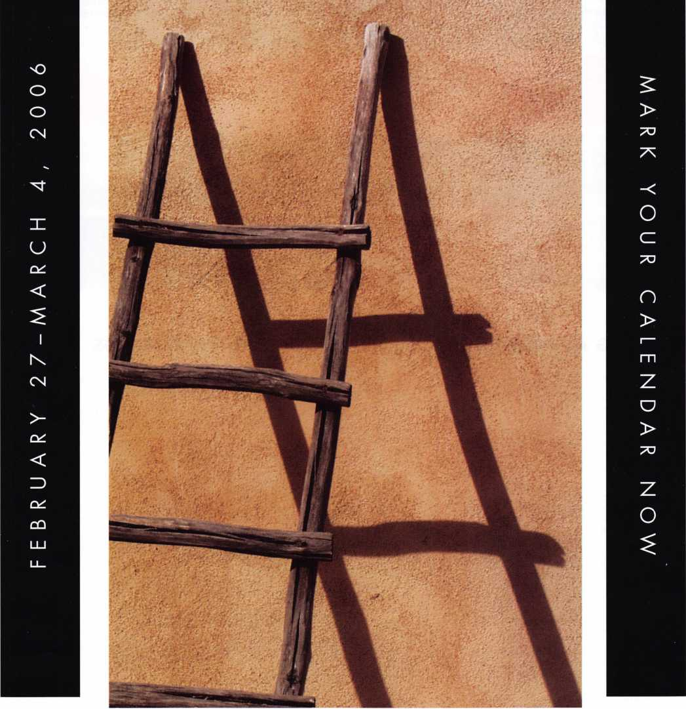

When it comes to learning about the latest in safes and vaults, time is of the essence. SAFETECH 2006 features an all-new menu of classes, covering every safe topic on the globe. Don't miss out!

SAVTA • 3500 Easy St. • Dallas,TX 75247 (214) 819-9771 Fax (214) 819-9736 Email: [convention@savta.org](mailto:convention@savta.org)

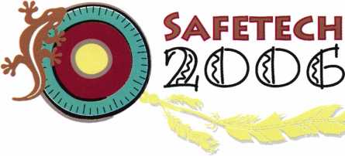

events

upcoming

|  |  |
| --- | --- |
| 04 Annual Oklahoma Master Lock­smith Assc. Distributor's Show Contact: Mike McGrew, CRL 918-333-9136  Oklahoma City, OK | 11 TLA 10-12 Minnesota Chptr Associated 27 SAFETECH 2006  Contact: 817-961 -0800 Locksmiths of America Safe & Vault Technicians Assc.  Ft. Worth, TX Education Weekend Annual Convention 2/27-3/4  Reservations, 651-770-281 1 Contact: [convention@savta.org](mailto:convention@savta.org)  Maplewood, MN Albuquerque, NM |
| 1-4 SAFETECH 2006  Safe & Vault Technicians Assc. Annual Convention 2/27-3/4 Contact: [convention@savta.org](mailto:convention@savta.org) Albuquerque, NM | 30-1 CLA Tradeshow & Convention  Contact: [www.eurolockfed.com](http://www.eurolockfed.com)  Ontario, CA |

5-7 ISC West

Las Vegas, NV

5-9 European Locksmith Federation  
[www.eurolockfed.com](http://www.eurolockfed.com)  
Venice, Italy

6-7 Oklahoma Master Locksmith

2-day session

Contact: Mike McGrew, CRL  
918-333-9136

Tulsa, OK • Holiday Inn Select

9/15-16 Doyle Security Products

20th Annual Trade Show & Educational Weekend

Minneapolis, MN

Contact: Chantelle Gallagher

800-333-6953

**UPCOMING ACE CLASSES UPCOMING PRP SITTINGS**

|  |  |  |  |
| --- | --- | --- | --- |
| 2/11/2006 | Detroit, Michigan • ACE Classes  Locksmiths Security Association  Contact: Robert C. Nobel, CPL | 2/12/2006 | Sunday 9:00 am • Maplewood, MN • Minnesota Chapter  Dana Lee 952-887-1199 |
| 2/10-12/2006 | 810-385-9329  Minneapolis, Minnesota • ACE Classes | 2/12/2006 | Sunday 8:00 am • Ft. Worth, TX • Texas Locksmiths Association 877-TLA-INFO |
|  | Minnesota Chapter of ALOA  Contact: Dana Lee, CML  612-968-4500 | 2/26/2006  3/04/2006 | Sunday 9:00 am • Fairborn, OH • Ohio Valley Chapter of ALOA  Bill Lockwood, CRL 937-775-2154  Saturday 8:00 am • Albuquerque, NM • SAVTA '06 Satetech |
| 3/16-19/2006 | Secaucus, New Jersey • ACE Classes  East Coast Region Security Show |  | Mayra Ocon 800-532-2562 x203 |
|  | Contact: Bill Timmann, CML  908-859-3135 | 3/18/2006 | Saturday 11:00 am • Somerset, NJ • MLANJ  Bill Timmann, CML 908-839-3135 |
| 4/22-23/2006 | White River Junction, Vermont • ACE Classes  Green Mountain Locksmiths Association  Contact: Bradley Manchester | 3/18/2006 | Saturday • Nashville, TN • Tennessee Org. of Locksmiths  Chris Cyree 931-455-0202 |
| 4/22-23/2006 | 802-863-4153  Fort Wayne, Indiana • ACE Classes | 4/01/2006 | Saturday 8:00 am • Ontario, CA • California Locksmiths Association Suzanne Harmony 714-632-6800 |
| 5/13/2006 | Northern Indiana Chapter of ALOA  Contact: Jeremy Rodocker, CML, CPS  260-459-1500 | 4/06/2006  5/11/2006 | Thursday 9:00 am • Dallas, TX • ALOA  Mayra Ocon 800-532-2562 x203  Thursday 9:00 am • Dallas, TX • ALOA |
| Detroit, Michigan • ACE Classes  Locksmiths Security Association  Contact: Robert C. Nobel, CPL | Mayra Ocon 800-532-2562 x203 |
|  | 810-385-9329 | 6/08/2006 | Thursday 9:00 am • Dallas, TX • ALOA  Mayra Ocon 800-532-2562 x203 |

? core

New GPLA Board

ALOA's President Robert Mock swears in the new Board of Directors of GPLA at the Officer Installation Dinner held at the Pennsauken Country Club.

From L to R. Bill Neff, Bob Thomas, Joe Ruestle, Bob Gress, Jimmy Armenakis, Ron Marcinkowski, Justin Trueland, Orvis Kline and Barry Wilensky.

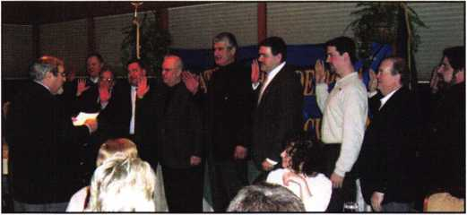

In Memory

An ALOA Member for 22 years, DeLane W. "Butch" Brechwald passed away on January 10th at 89 years. Butch retired from locksmithing several years ago. His funeral was held on January 16th in his home town of Shenandoah Iowa.

Jay Nelson from Philadelphia passed away on December 23, 2005. Jay was a Charter Member of the GPLA and of ALOA. The longtime owner of Mercer Lock Co. and beloved husband of Rita Nelson (nee Maguire); devoted father of James J. Nelson will be missed. In lieu of flowers donations in his name to the charity of your choice would be appreciated.

ALOA Members Make Local News

Headline: "100-year-old firm has lock on growth Rolland Safe & Lock is evolving along with its tech-heavy industry"

View the entire story at [www.dallasnews.com](http://www.dallasnews.com). January 3, 2006 Tuesday SECOND EDITION BUSINESS; Pg. ID

MADIGAN SEEKS TO CLOSE DOOR ON PHONY STOREFRONT LOCKSMITHS

Chicago — Attorney General Lisa Madigan sued two New York locksmith compa­nies and their owners and officers for setting up fake addresses and phone num­bers in Illinois that led locked-out consumers to believe they were dealing with a local company, when in fact their calls for help were dispatched to the Bronx, New York, and, often, unlicensed Illinois locksmiths were instructed to respond. Complaints were received from Cook, DuPage and Lake Counties.

Madigan's lawsuit names as defendants Price Line Locksmith, Inc., a New York corporation, doing business as Priceline Locksmith, Inc., and Locksmith 24 Hours, Inc.; Gilad Gill, individually and as President of Price Line Locksmith, Inc; David Sasson, individually and as President of Price Line Locksmith, Inc.; Superb Solutions, Inc., a New York corporation; and Shlomo Hadar, individually and as President of Superb Solutions, Inc.

Madigan alleges that Price Line solicited and advertised for at least 17 compa­nies under assumed business names that claimed to be Illinois-based businesses. However, outside of their registered agent's location in Skokie, the defendants do not have a location in Illinois. The ads for the companies with the assumed busi­ness names were placed in the Yellow Pages, on various Internet Yellow Pages' search engines, its own individual Web sites at [www.chicago-locksmith.com](http://www.chicago-locksmith.com), [www.USATotalSecurity.com](http://www.USATotalSecurity.com) and on telephone directory assistance.

Additionally, Price Line is not licensed to do business in Illinois under any of the assumed business names used by Price Line.

"It's time to close the door on a New York company that does everything in its power to represent that it's a local Illinois company," Madigan said. "Price Line not only operated several phony businesses, they employed questionable prac­tices when actually doing locksmith work."

Those questionable practices included drilling consumers' locks instead of picking the locks, which in itself is more expensive and requires the extra cost of replace­ment locks; trying to charge customers more for work than was quoted over the telephone; giving consumers receipts stamped "Priceline Locksmith...Servicing the Great State of Illinois" when consumers thought they had contacted an entirely different company; and charging consumers for installing locks allegedly of a cer­tain quality when in fact they were a lesser standard.

In one instance, a 67-year-old Streamwood man went to the police department after he was locked out. The police called what they thought was a local lock­smith from the Yellow Pages. When the locksmith arrived, the consumer asked to see his license, which he did not show. Against the consumer's objections, he drilled the lock open and installed a new lock. Upon completing his work, the locksmith wrote a bill for $1,709.20, which had Price Line Locksmith stamped on to it. The consumer, who paid with a credit card, called his credit card company, only to find out that the charge was made to yet another business, Superb Solutions Locksmith.

An Evanston consumer searched the Web site [www.chicago-locksmith.com](http://www.chicago-locksmith.com) for a locksmith to have the front and back doors re-keyed on his recently purchased condominium. He was quoted a rate of $80 per cylinder for the lock changes.

The next day, a locksmith showed up and told the consumer it was necessary to replace the entire lock for the back door because the consumer did not have a key for that door. The locksmith said he was installing a heavy duty lock and the consumer agreed. The bill was $359 from Price Line.

The next day, the front door lock that was re-keyed broke and the front door would not open. The consumer contacted Price Line, which agreed to send a tech­nician, but no one showed up. The consumer finally contacted a truly local lock­smith and paid $174.50 for the door to be repaired. A few days after Price Line's work, the consumer found on the back door replacement lock box and the manufacturer's Web site that the alleged "heavy duty" lock was only standard duty, even though Price Line charged more to install that lock.

In another instance, a Matteson consumer was locked out of her car during lunch in the South Holland area. She dialed directory assistance for a local locksmith and was given information for Triple AAA Locksmith and 24hr South Holland Locksmith. Both had the same phone number. While one of the businesses said it would be right there, she waited 45 minutes.

Before opening the car door, the locksmith told the consumer it would cost her $65 for the initial phone call and $165 to open the door. The bill, with $32 added in taxes, came to $272 and was stamped Price Line at the top. After paying the bill with her credit card, the consumer called Price Line and told them they lied about where they were located, the price for their lockout servic­es and the timely delivery of such services. She also called directory assistance to get the addresses of the locksmiths, and was given a Park Ridge address for one and a South Holland address for the other. The consumer filed a dispute with her credit card company after she discovered that the charges were billed to a New York address.

Madigan's suit seeks to prohibit Price Line from doing business in Illinois, revoca­tion of any and all licenses to do business in Illinois, a declaration that all con­tracts with consumers are unlawful and that restitution is paid. The lawsuit also seeks a civil penalty of $50,000 and additional penalties of $50,000 for each violation found to have been committed with the intent to defraud. Additionally, the suit seeks $10,000 per violation committed against a person 65 or older.

"Consumers who face emergency situations such as lockouts often are targets for con artists," Madigan said. "We allege that Price Line preyed upon this stress and in the process, broke the laws of our state."

The case is being handled by Assistant Attorney General Henry Ford, Jr., in Madigan's Consumer Protection Division.



Keynotes • February 2006

specialty locks:

Padlocks Offer Enhanced Safety and Security

Brady Padlocks Designed for Lockout and Industrial Use

Brady has introduced two new padlocks designed for use in lockout and other industrial applications.

The Brady Safety Padlock complies with all applicable OS HA lockout requirements. The Safety Padlock features a special six-pin cylinder that resists tampering. It also results in more unique key cuts; reducing the likelihood that one worker's key will open another's lock.

The Safety Padlock lives up to its name. The body is non- conductive and resists sparking, making it a safer alterna­tive than metal locks when used in proximity to electrical equipment. The patented non-conductive key chamber prevents an electrical charge from traveling from the shack­le to the key.

The Safety Padlock is compact and lightweight, and con­structed of reinforced nylon for superior chemical, corro­sion and temperature resistance. The body is ribbed for sure gripping by workers, even when they are wearing gloves.

The Brady Steel Padlock is designed for a wide range of heavy-duty industrial applications, including lockout and

the securing of toolboxes, equipment cribs, and parts and materials storage areas. The padlock features a five-pin cylinder, instead of the four-pin cylinder found in most other locks, making it more tamper-resistant and reducing the chance one worker's key will open another worker's lock. Countersunk rivets and a hardened steel shackle pro­vide added protection, while a paracentric keyway with drill protection makes the lock difficult to pick.

The Steel Padlock is built to withstand heavy use in the toughest industrial applications. It is also resistant to chem­icals and corrosion. With many locks, body plates are coat­ed only after they are laminated together. The body plates on the Steel Padlock are individually coated prior to lami­nation for maximum rust prevention. This zinc coating is "self healing." If the lock is scratched, the coating migrates to seal itself.

A selection of distinctive safety colors, custom keying, charting and imprinting are available for both the Safety Padlock and Steel Padlock. Brady also offers aluminum and brass padlocks.

**10**

Keynotes • February 2006

specialty locks:

Padlock Design Incorporates Tamper Indicating Feature

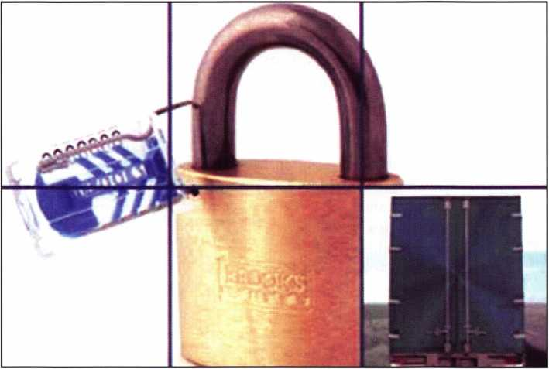

The padlock has served as the most stalwart means of deterring and preventing theft since the Middle Ages. It does, however, have a drawback; once opened and mer­chandise it is meant to protect is pilfered, there's no indica­tion of the event. That's because the traditional padlock can simply be re-closed without any evidence of where, when or even whether it had been unlocked. To overcome this shortcoming, BROOKS has developed a line of tamp­er indicative, brass padlocks. As part of a comprehensive security tracking system, the BROOKS Indicative Padlock will promptly reveal that it has been unlocked, which helps isolate the time and place of its opening.

Using BROOKS' indicative padlocks  
within a security tracking system will  
further indicate when a padlock has  
been opened. A security tracking sys-  
tem calls for a uniquely numbered

seal to be visually inspected and verified at regular inter-  
vals, as well as at each point when custody changes. Should  
the disposable, indicative seal be missing, it would suggest  
that the padlock might have been opened since its last veri-  
fication. Therefore, it will help identify the timeframe and  
the place that it had most likely been removed.

BROOKS Indicative Padlocks are available in a wide choice of corrosion-resistant body sizes, shackle materials, shackle lengths and diameters. BROOKS Indicative Padlocks can be keyed alike or differently, master keyed or grand master keyed. Furthermore, they can be keyed to the most popular keyways such as Master, Corbin, Yale, Best and others).

BROOKS Indicative Padlocks are unique because they feature a hole, which passes through the locking body and shackle when the padlock is engaged. Threading a BROOKS plas­tic or wire seal through the hole pre­vents the lock from being opened without having to first remove the seal. Thus, if the seal is missing, it is evident that an attempt to open the lock had occurred.

Keynotes • February 2006

specialty locks:

Locknetics Computer-Managed Locks Secure Drawers & Cabinets

No More Lost Keys Protects Medications & Equipment Helps Hospital Meet JCAHO Regulations

IR Security & Safetys Electronic Access Control Division  
(EACD) announced that internationally-acclaimed Loma  
Linda University Medical Center (Loma Linda, Calif.) is  
securing medications and special equipment kept in  
approximately 100 drawers and cabinets while enhancing

its nurses  
accessibility to  
them with a  
Locknetics  
On Board  
standalone  
access control  
locking sys-  
tem.

Computer  
Managed  
(CM) door  
locks and cab-  
inet locks are  
placed  
throughout  
the medical  
center, outpa-  
tient dialysis

unit, ER and the community medical center. Nurses open the CM door and cabinet locks by simply entering their own special codes on the locks keypads and pulling their levers. Their use complies with JCAHO (Joint Commission on Accreditation of Healthcare Organizations) regulations.

Nurses from our critical care units were constantly losing their keys to drawers and cabinets that contained medica­tions and special equipment, remembers Ken Hendricks, Loma Linda University Medical Center supervising lock­smith. All too often, I would get a call to come down to the Medical Center at 2:00 am in the morning to re-key a

lock. That no longer happens since we installed the CM battery-powered locks on the drawers and cabinets. These locks have been very reliable.

According to Hendricks, even after migrating from stan­dard cabinet keys and locks to high security keys and locks, it was still difficult to manage keys. Due to budget con­straints, staff did not want to go to the expense of installing a hardwired system. With the standalone CM system, they match the benefits of a hardwired system, being able to give each user his/her own credential, assign time dependent access privileges if desired, and even down­load audits by simply connecting a laptop to the CM lock.

No longer do nurses or the locksmith staff have to keep track of keys, making both more productive. The entire locking system is contained within the drawer. Each nurse has her/his own numerical code as does the pharmacy. Audit trails on the last 1000 events are recorded, allowing the Medical Center to keep close track of who went into any specific drawer or cabinet and at what time. If some­thing happens, the locksmith staff can attach a laptop to the lock and download the information.

The CM locks are also placed on the Centers Herman Miller plastic storage units, a low portable cart with draw­ers, used both on patient floors and the ER. Since it is con­venient to keep medications and special equipment in these nurse servers, a high security lock is required. Other CM locks secure large stationary Herman Miller cabinets.

As Hendricks contemplates migrating to a campus-wide multi-function smartcard, the CM locks will fit right in because they also work with other credentials such as iButtons, magnetic cards, HID proximity cards and bio­metric handreaders besides the presently-used keypads.

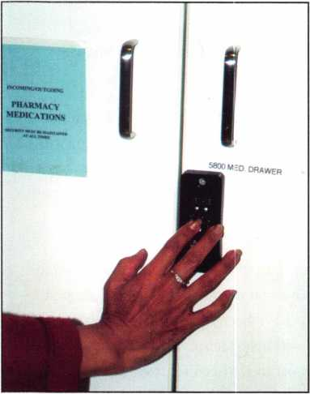

Keynotes • February 2006

Mm

■■

It retrofits virtually any door and has all the style and

SECURITY HOMEOWNERS WANT. That’s WHY IT’S ALL YOU NEED TO CARRY

*Introducing the Schlage* Accents™ *Collection*

Schlage now provides you with the ability to retrofit virtually any door with the ultimate in elegance and security. The Schlage Accents collection is built on a revolutionary chassis designed to provide field-reversible levers on passage, privacy and now keyed functions. A patented adjustable through-bolt allows Schlage Accents handlesets to retrofit over 70% of competitors’ current designs. Special features like these, along with concealed screws and decorative trim, allow you to reduce the inventory you carry while providing the perfect door hardware choice for homeowners who desire Schlage quality and security.

**To find out more about the finest line of decorative door  
hardware, visit schlageaccents.com.**

*Timeless beauty*

An(f#l)lngersollfiand business

© 2005 Ingersoil-Rand

WPiMMMWMM

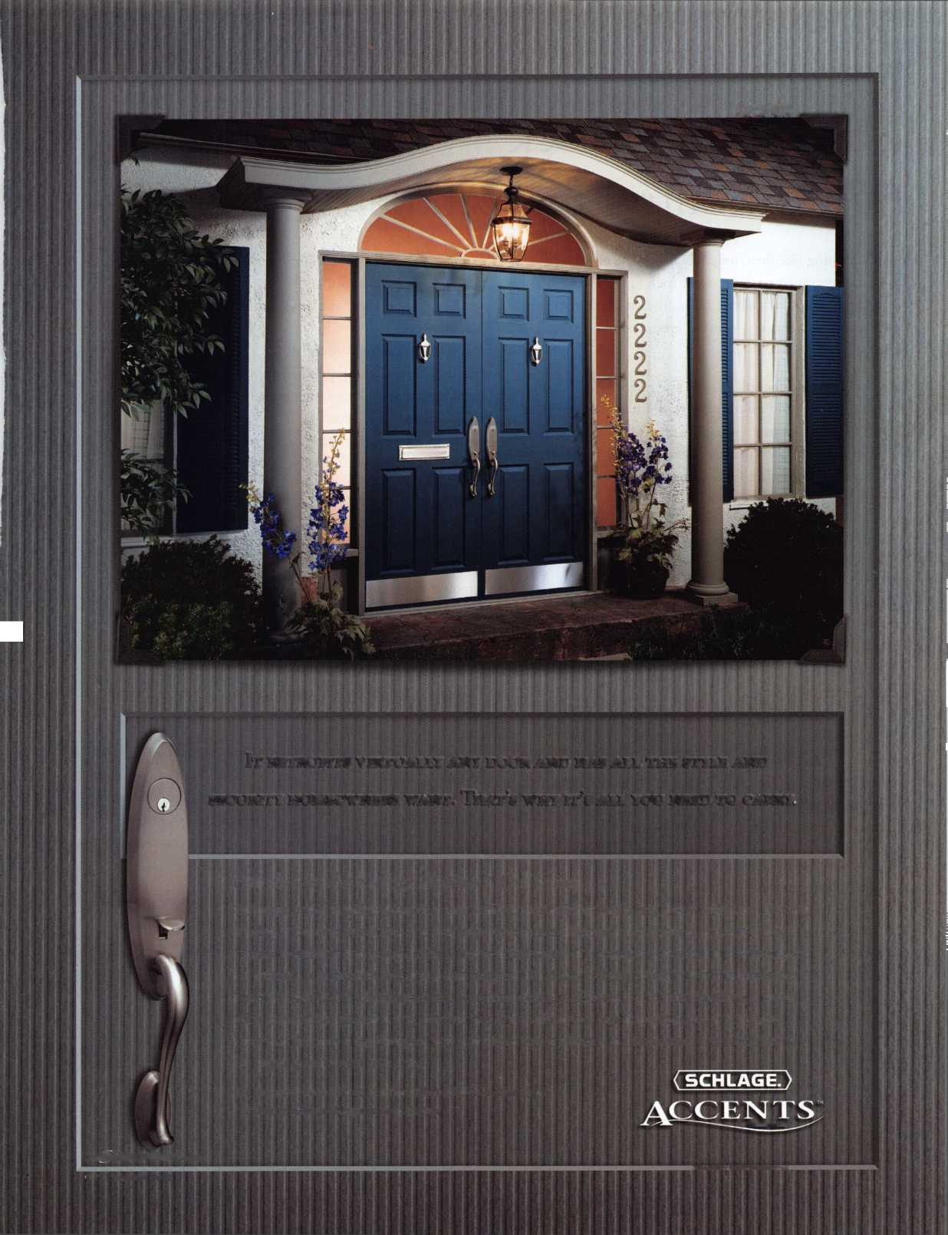

specialty locks:

The CompX eLock® — Revolutionizing Access Control for Cabinetry

There’s nothing like the CompX eLock®. The eLock is a standalone access control electronic lock for cabinetry that can be used almost anywhere: in healthcare, academics, gov­ernment, manufacturing — anywhere access control is required.

Also available: the CompX eLock® refrigerator kit! Providing the same security and monitoring capabilities as the original eLock, the refrigerator kit secures your cold storage. Perfect for pharmacies or cafeterias, the CompX eLock® refrigerator kit is another innovation from CompX Security Products that puts you in control.

Just some of the CompX applications include:

* patient records
* drug / supply cabinets
* coolers / refrigerators
* bio-hazard disposal
* lockers
* dorm room lock boxes
* research labs
* key control boxes
* tool cribs / carts
* evidence rooms
* equipment storage
* cafeteria / food storage

eLock®

The CompX eLock® is

available in five models:

* EL-2004-KP: numeric  
  keypad
* EL-2004-MS: track two mag stripe card reader
* EL-2004-MSKP: combination of magnetic stripe card read­er and numeric keypad; users enter both credentials or just one
* EL-2004-PR: HID proximity card reader
* EL-2004-PRKP: combination of proximity card reader and numeric keypad; users enter both credentials or just one

Other CompX eLock® features include:

* 250 user or supervisor codes
* Add or delete users at the unit even without LockView® software
* Use your existing credentials
* Motor driven latching mechanism
* 4AA battery pack mounts remotely
* Low battery indicator
* “Jump start” 9-volt battery power port allows users to access the eLock even when batteries are exhausted

LockView® Software from CompX Security Products is a WindowsTM based software program (sold separately) that, when used in conjunction with the CompX eLock®, allows supervisors to monitor audit trails for the last 1500 access attempts with date, time and user name.

* Download, view, save, print, archive and delete audit trails
* Dual credential access available
* Time based access restrictions

Together, CompX eLock® and LockView® software put you in total control.

For more information, or to receive literature about the CompX eLock and the new CompX eLock® refrigerator kit, contact your sales representative or contact CompX Security Products directly. CompX Security Products • PO Box 200 • Mauldin, SC 29662 • 864 297 6655 phone • compx.com • [eLock@compx.com](mailto:eLock@compx.com)

CompX Security Products® designs, manufactures and mar­kets high-quality security products through three domestic manufacturing facilities under four distinctive brands:

CompX National, CompX Fort and CompX Timberline. As a market leader, CSP collaborates with customers from the ini­tial product stage and application design to manufacturing, for both OEM and distribution channels. CSP’s resolute adherence to high product quality and exceptional customer service, along with continuous product improvement and operational efficiency, is the foundation of its strategy to maintain long-term customer relationships.

Keynotes • February 2006

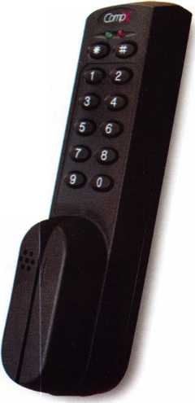

ALOA

**2 Million**

Customers at Your Fingertips

Internet Shoppers are loaning far a locksmith Right Now!

**FREE ENROLLMENT!**

ALOA Partners with ServiceMagic® to give members discounted access to leading online marketing solution. Through the  
relationship, our members will now have access to ServiceMagic's online marketing solution that can dramatically  
increase revenue and profits.

As an ALOA member, you can now receive targeted cus-  
tomer leads from consumers looking for a locksmith in  
your area through ServiceMagic. The program gives you  
immediate access to ready-to-buy consumers.

* Increase Your Customer Reach - ServiceMagic gets you access to more than 2 million unique visitors and  
  more than 150,000 consumer leads each month.
* Target Your Leads - Get matched consumers looking for locksmiths in only the locations you want to work.
* Increase Your Profits - Service Professionals who have used ServiceMagic for at least a year report grow-  
  ing their business by 28% on average. Many report that ServiceMagic has become their lowest-cost form  
  of advertising.

Free Enrollment Fee for a Limited Time - On behalf of the Associated Locksmiths of America,  
save $99 by enrolling now.

Unlike other marketing initiatives, with ServiceMagic there are no long-term contracts or ongoing monthly  
or annual fees. Once in, you pay only for the targeted customer leads you receive. To learn more, please visit:  
[www.servicemagic.com/ext/771036](http://www.servicemagic.com/ext/771036)

To learn more, visit

<http://www.servicemagic.com/ext/771036>  
or call 888.528.9179

**SERVICE!**

**MAGIC”**

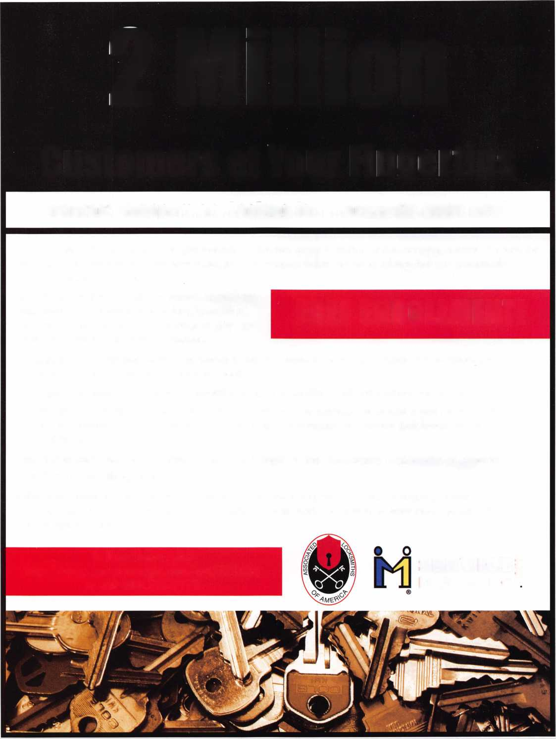

specialty locks:

Slide Bar for Safer Gate Access

Safety specialist Fortress Interlocks has introduced an ingenious new design of Slide Bar for use with its AutoStop gate switch unit. The robust Slide Bar, cast from stainless steel, can be used on both hinged and sliding doors and provides an enhanced level of safety without compromising functionality and ease of access.

The Slide Bar is a long bar with an actuator at the head. When the door is shut, the slide bar is easily pushed along and the actuator tongue engages with the AutoStop unit, turning the power on. When the door has to be opened, it is easily retracted, removing the actuator from the unit and turning the power off. A spring loaded version is available for high vibration applications.

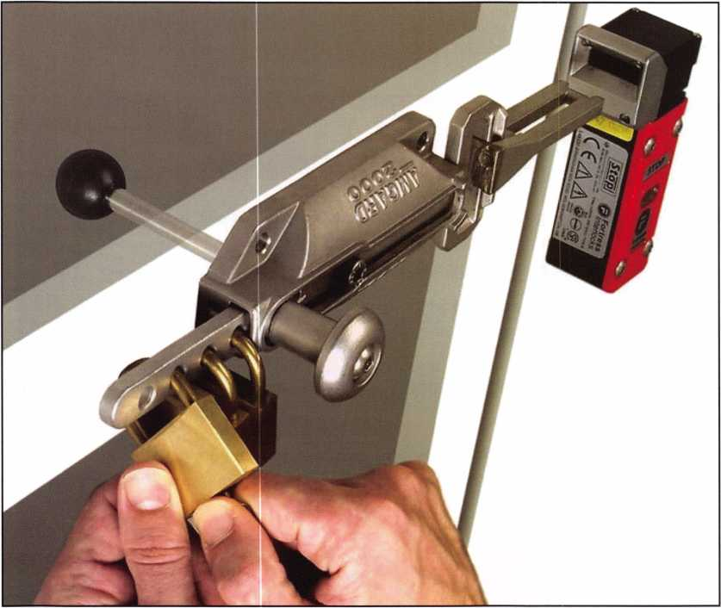

As well as providing all the safety features of a gate switch, the Slide Bar design ensures the power cannot be turned on simply by slamming the door behind an operator. The Slide Bar also features padlock holes for lock-out opera­tions and an internal release handle which acts as an emer-

When the bar is retracted  
and the tongue is out,  
padlocks can simply and  
easily be inserted into the  
bar preventing the  
machine from being  
restarted while operators

are still within the hazardous area. In addition, the casing  
is designed so that the padlock holes are impossible to use  
when the slide bar is in the shut position.

As the bar has to be slid  
into position to re-ener-  
gize the machine, closing  
the door and returning  
the power has to be a  
deliberate action that can  
only be done from the  
outside. On the inside of  
the door is an internal  
release handle which  
allows the bar to be  
retracted from the head  
from inside the guarding  
but cannot be used to  
insert the actuator into  
the head.

gency stop.

Keynotes • February 2006

specialty locks:

Power Isolated Safely With New Bolt Interlock from Fortress

Industrial safety specialist Fortress Interlocks has introduced two robust, modular, mechani­cal bolt interlocks. BM (bolt module), and stainless steel version BMS, have been designed to interface with devices such as power breakers, valves, and earth switches, indirectly interlocking power sources. Part of the mGard range of modular interlocks, these power isolation devices are designed to ensure that all energy sources are reduced to zero before access to potentially hazardous machin­ery is possible.

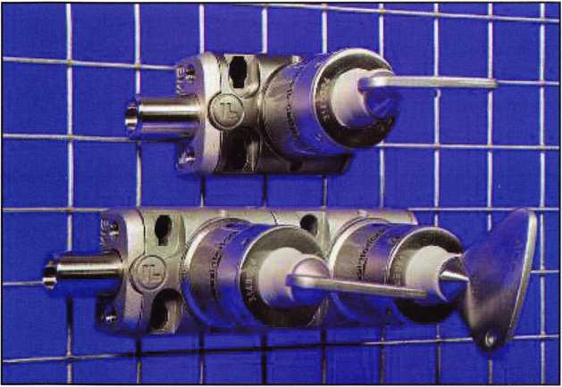

Fortress offers a patented sequencing system with up to 39,000 different sequences in a ten multiple module arrangement. The slim and attractively designed BM and BMS need minimal maintenance and have been tested to over 1,000,000 operations. There are no product handing issues and horizontal and vertical mounting is available.

In conjunction with the BM, Fortress has launched DM (door module), a robust, modular access interlock suitable for use on all types of doors, and XM (exchange module) a modular, mechanical trapped-key interlock that is used to exchange one or more keys for a number of other keys.

BM is available as a single access lock, or with  
up to ten multiple access lock modules, elimi-  
nating the need for separate key exchange

boxes. Easy to configure, the units can be extended or  
trimmed down and the surplus modules used elsewhere.

With a single module, when the key is free the bolt is usu­ally in the extended position. To retract the bolt the key must be inserted and trapped. A reverse sequence is avail­able on request. The operation of the key extends or with­draws the bolt, which interfaces with mechanical linkages such as levers or cams on proprietary switchgear applica­tions.

With multiple modules, when the primary key is free the bolt is usually in the extended position. To retract the bolt the primary key must be inserted, turned and trapped in the primary lock, and any secondary keys turned and removed from the secondary lock. Other sequences are available on request.

Keynotes • February 2006

specialty locks:

New Cam Locks from Southco Offer Durability and Design

A specialty line of cam locks from Southco is designed specifically for panels that require secure key-locking or manual access without compression. These new cam locks offer smooth, consistent operation with a modern, stylized appearance. They are durable and are ideal for applications that must meet demanding the NEMA 4 and IP-66 requirements where dust, dirt, and liquid contaminants are an issue.

The distinctive styling of these cam locks complements modern enclosure and cabinet design, as well as other Southco access hardware, allowing for a consistent look throughout an application. Standard finishes for these latches include chrome plate or black powder coat. These cam locks feature a stainless steel lock cover for scratch

resistance and an O-ring for a complete seal of the internal  
latch components.

Available in two styles, these latches operate with an easy  
fraction of a turn. The manual-operated wing-head style  
offers a detent in both the open and closed positions, pro-  
viding a positive indication of opened/closed status. The  
second style provides multiple key-codes for secure,

restricted access. An overmolded key cover  
with custom logo imprinting is available.  
Contact Southco for details.

Four standard cam offsets are available to  
accommodate a wide grip range. Each cam  
latch can be installed with positive or nega-  
tive offset for even more flexibility.  
Additional options in the housing length can  
help accommodate various panel thicknesses  
and application differences. Southco cam  
locks are also available in either clockwise or  
counter-clockwise rotation for left-and right-  
hand installations. The latches install quickly  
into a standard three-quarter inch double-D  
shaped hole.

Southco cam locks can be used in a variety  
of applications, including enclosures, kiosks,  
and electrical/control equipment, vending  
equipment, furniture, food service, RVs, and

off-highway equipment. They are backed by Southco s full  
line of engineered access solutions and complement the  
company’s existing range of products, providing customers  
a single source for all their access hardware requirements.

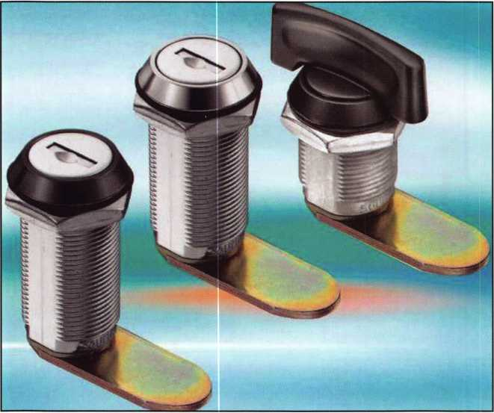

**8**

Keynotes • February 2006

**IAS VEGAS**

£verY

b0dV Wa«fs it

FKI

SECURITY GROUP

**/fn)** Security & Safety

Vff- PravtR Source. Proven Soiuttons:

**. You** MIGHT TAKE

IT HOME!

One Lucky Member Attendee at ALOA  
2006 is going home with this gorgeous  
mint-condition 1956 Ford Thunderbird.

A ticket will be given to each ALOA  
Member who registers and attends the  
show. Someone has to win it, and it  
might as well be YOU!

(Must be present to win. Exhibitors,  
Employees. Family Members of Employees, and  
nonmembers are not eligible for this door prize.)

SECURITY PRODUCTS

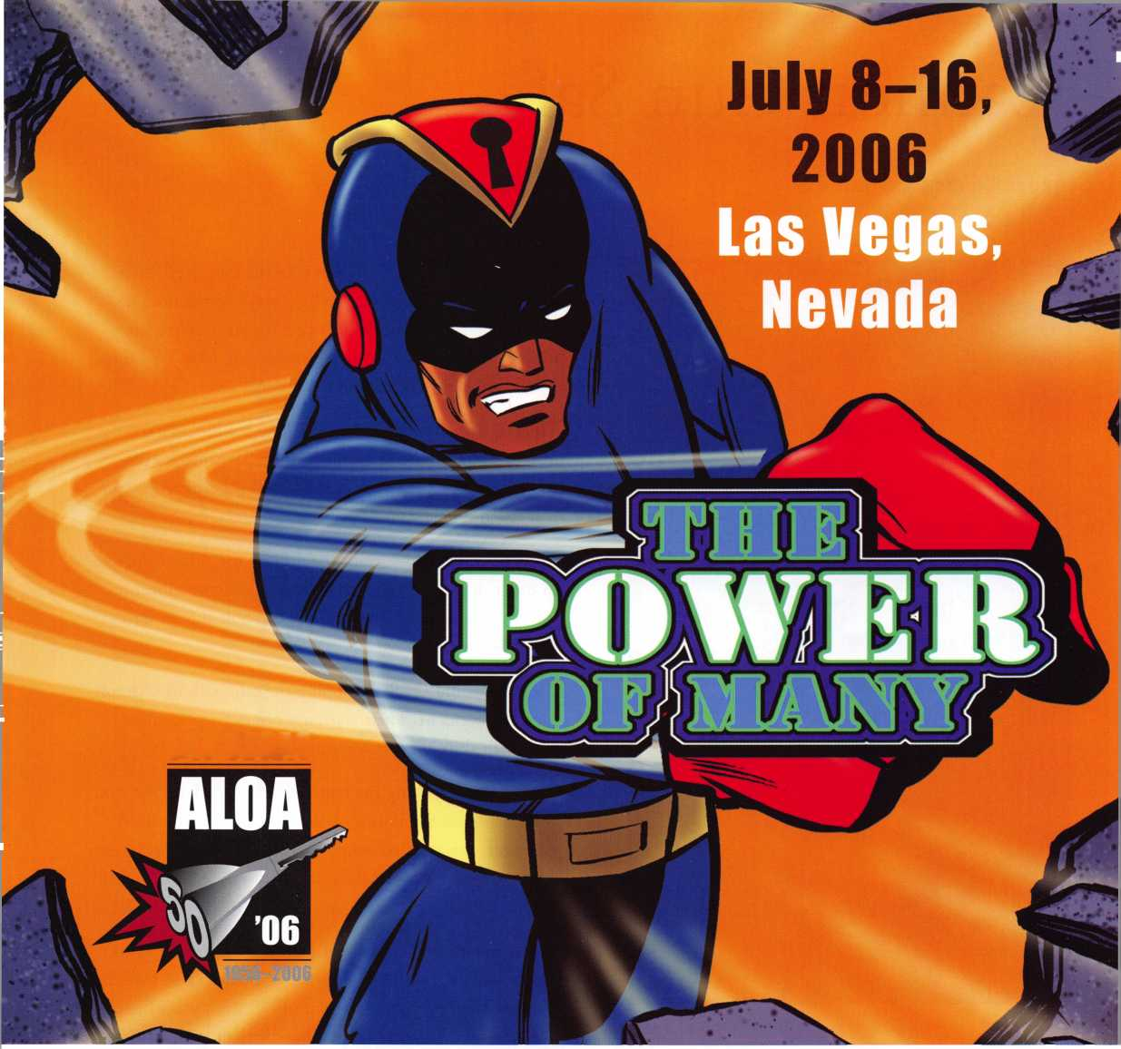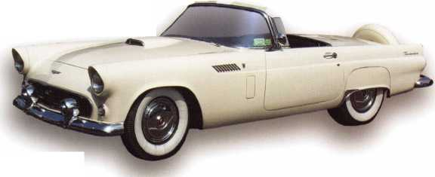

Cannon Gun Safe

by Greg Perry, CML, CPS

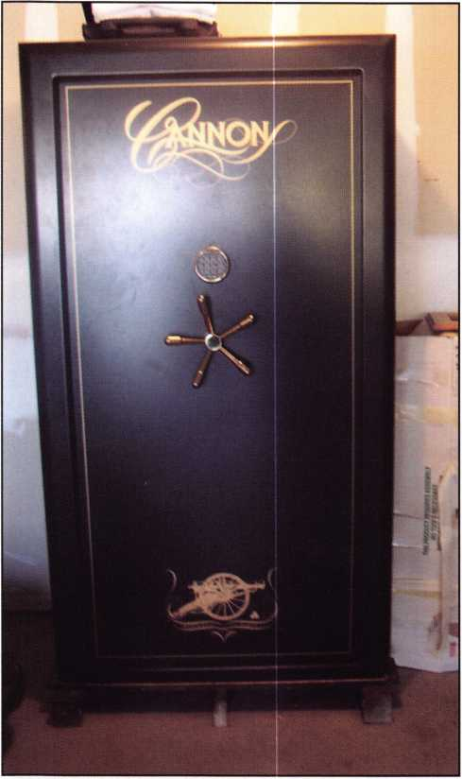

Photo 1

There are times when I like to take the long way when opening a safe. Why take the long way? Sometimes, its less damaging to the safe or makes for an easier repair. Other times, I just want to try something new. This time,

I took the long way and hit a roadblock.

The call came about a Cannon. “The handle on a six- month-old gun safe just spins”, the caller said. We dis­cussed the possible causes. I wondered if perhaps the cam had fallen off the handle shaft.

I was given the dimensions for drilling the side of the safe in order to push the bolt rack back. I also got a location for fishing the lower bolt up. The top bolt should have fallen because of gravity.

This job would involve shipping the safe back to Cannon for a replacement. Their warranty offers a replacement safe, with shipping at Cannons expense.

I asked about drilling the handle shaft to pick up the cam and fishing for the bottom bolt. If the cam had indeed fallen off, this method might work. Cannon sent drawings with dimensions of the safe, just in case I decided to drill for the bolts.

I tried to pull the handle and shaft out of the safe. This didn’t work so I drilled the center of the hub and threaded the hole to use a bolt to press it off. Once it was off, I drilled down the center of the handle shaft with a small hole using ViceGrips to hold the shaft. Slowly enlarging

Keynotes • February 2006

Simple to use, install, and maintain. Basic digital entry as  
simple as a single stand alone digital keypad for economical  
applications - or programmable digital keypads with access  
for hundreds of users and multiple doors and/or gates.

Complete systems that can include electric locks and  
access control devices linked to weigand control boards -  
all manufactured by DKS.

* Durability - backed by more than  
  50 years of Made-in-the-USA  
  manufacturing and expertise
* Outdoor use in all weather
* Easy to install magnetic  
  locks for both doors and  
  gates - a full line available  
  from 300 - 1200 lbs  
  holding force
* Vandal resistant - DKS

keypads feature:  
stainless steel  
faceplates, galvanized  
steel sub-plates, and  
rugged steel cabinets

Fusli Button

To Cal

3000

000300

00000000

00000000

00000000

00000000

300000

0030

We use DoorKing because they have a full line of products which provides us with one-stop shopping and they have a great customer service departmentV

*Scott Brose, Bejan Souferian* Co-Owners, Scotland Entry Systems, Inc.

Van Nuys, California

ACCESS CONTROL SOLUTIONS

for over fifty years

**surface mount**

**Locking and Entry**

**single and multi-door access control**

**flush mount**

**magnetic lock**

*mm*

**1504 with intercom**

**id Manufacturing a full line of product since 1948**

**Parking Control**

**Gate Operator**

**Telephone Entry**

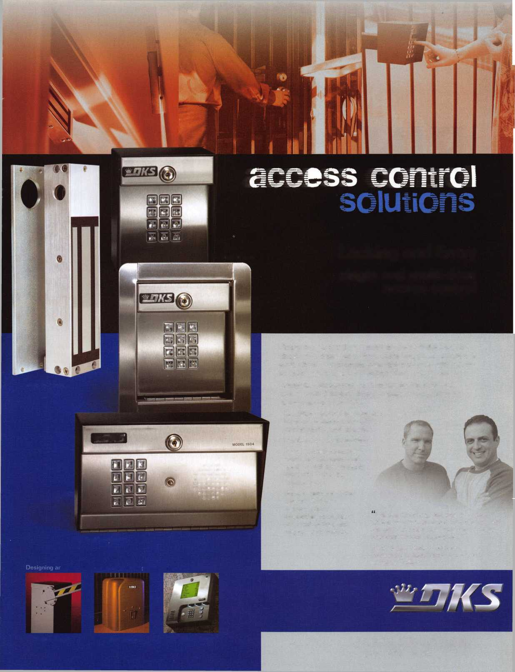

I •

**RING of a KING**

Sponsorships

Member Name

Kwok-kei Leung .

Henry W. Raymond ..

Yuriko Yanai

Mary S. Ohmit CPL

Charles C. Robertson CML

William Lee CRL

Jack HobinCPL

Clifford D. Lipscomb CML, CPS

Michael B. Groves

C Allan Halverson

David M. Troiano

Myeong-Rae Cho

Jim Williams CRL

David M. Lowell CML, CMST

Salvatore J. Dulcamara CML

Dana L. Barnum CML

Barry K. Leas CRL

Danny W. Rudd CPL

Larry A. Warnick CML

Eugene R. Altobella Sr

Jeanne G. Lodge CML

Robert D. DeWeese CML

Scott L. Henke CPL, CPS

Dallas C. Brooks

Breck H. Camp CML

Lawrence F. Smith Jr, CML

John C. Elliott Jr, CML, CPS

Marian M. Swann CRL

James M. Watt CML, CPS

Robert W. Duman Sr, CML

William L. Young CML, CPS

Anthony J. Ramunno CML, CPS

Jeffrey S. Nunberg CML, CMST

J Thomas Hood CML

Ken Dale

Robert H. Stafford CML

Philip A. Rovenolt CPL

William T. Beranek

John L. Shandy CML

Elvis D. Hammerschmidt CPL

Jerome L. Cohen CML

Peter K. Gauthier CPL, CPS

Man-Soo Seo RL

James J. Cawby CML, CPS

James L. Hancock CPL

Hans Mejlshede CML

John S. Dorsey CML, CPS

Thomas G. Vandersteen CML, CPS .

Michael C. Olson CRL

Peter Sarailian CRL

Walter W. Lascar RL

Keizo Takahashi CRL

James E. Fowler Sr, CML

David C. Harris CML

Ronald E. Heidzig

Joe J. Lee CRL

Takashi Kuwana CRL

Eugene R. Altobella Jr

Ernest W. Wright

Peter R. Hall

William P. Grant CRL

James E. Gruber CPL

Evelyn V. Wersonick CML, CPS

Joseph P. Ferrero CML

Gary F. Teams CPL

Kenneth E. Kim CRL, CPS

Joseph W. Whitaker CPL

William J. McElheney CML

John W. Soderland CML, CMST

Michael E. Jordan Jr, CML

Jon B. Griswold CML

Brian J. Reetz

Donald H. Shiles RL

John A. Ilk CRL, CPS

Russell P. Fuller CRL

Robert C. Rodocker CPL

John J. Greenan CML, CPS

Steve L. Cothran

Leonard J. Passarello CPL

Bruce J. Tarbet CML, CPS

John D. Cannon CML

Paul M. Souber

James T. Brickler CPL

Calvin G. Harris CML

Frank D. Hartung CML

Rolando Bouza

John F. Engel CRL

Richard C. Sievers

Brooke P. Berry CRL

William J. Wickward CML

Raymond C. Lusk CML

Robert M. Massard CRL, AHC...

Gregory L. Perry CML, CPS

Eric F. Veal

Barry L. McMenimon CRL

Thomas J. Demont CML, AHC ...

Basil W. Shannon CPL

Ralph O. Warren CML

Gordon R. Racine CML

Bruce P. Eagan CML

Kevin R. Wilson CML, CPS

Timothy K. Chow

Dale L. Knowles CPL

Timothy J. Moore CRL

Andrew A. Edmunds CML, CPS.

Maurice R. Horne CML

Daniel S. Enriquez CRL

Gene Eldridge CPL

Ronald P. Riggins CML

J Casey Camper CML, CPS

Charles E. Haas CML

Robert E. Mock

Lester S. Brodsky

Larry L. Votaw CML

Thomas R. Smith CPL

Todd K. Ladwig CML, CPS

William T. Straub CML

Randy L. Hutchison CRL

Richard T. Johnson CPL

Carroll T. Mann

Vincent L. Formon CML, CPS

Carroll T. Croson Jr

Marian E. Sagar

Andrew S. Dennison CPL, CPS . Kenny R. Carroll

How can I join the President's Club?

You can earn a membership in this prestigious club by recruiting  
just 10 new members for ALOA.

*Any ALOA member may participate.

What do I get?

When you recruit 10 members, you receive a  
handsome blue blazer with a President's Club crest.

You also get the satisifaction of knowing that you are  
helping your association, helping your industry grow,  
and you are helping fellow locksmiths achieve success.

How do I get started?

Mail the form below to the ALOA office for a supply of  
applications (800) 532-ALOA or FAX (214) 819-9736.  
One President's Club credit is awarded for each new  
applicant. Credit is awarded only after the membership  
application is approved. However, the credit will apply  
for the period in which the application is received.  
Failure to identify yourself as the sponsor on the applica-  
tion form at the time it is submitted to ALOA for  
processing will forfeit any credit.

|  |  |
| --- | --- |
| Yes! 1 want to join the ALOA President's Club.  Please rush me applications so 1 can start earning credit toward membership in the club! | |
| Name |  |
| Company |  |
| Address |  |
| City Sta | te Zip |

Mail this form to ALOA • 3500 Easy St. • Dallas, Texas 75247-6416

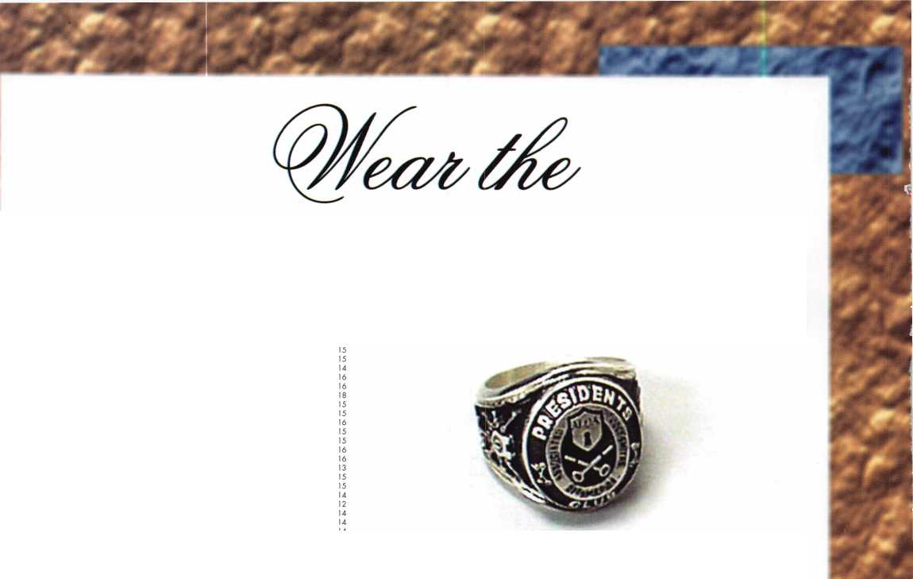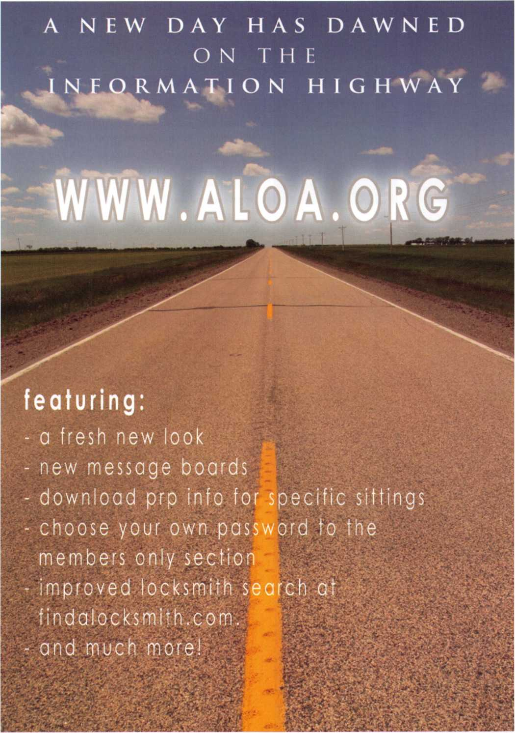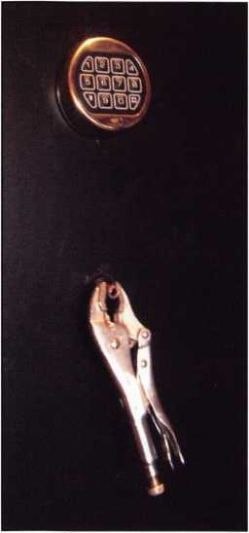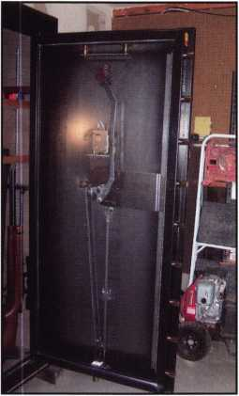

Photo 3

Photo 2

the hole to 7/16”, I finally had most of the shaft removed. This allowed me to break the balance of the shaft inside the safe and look around. I could see the cam. It had not fallen off. I drilled a couple of holes in the cam and tried to turn it with a screwdriver as the customer entered his code into the LaGard LG Basic electronic lock.

If this safe had a mechanical lock or an electronic lock without automatic relock, I think this might have worked. The problem was that the lock would automatically relock within a few seconds of entering the code. This safe also had a bolt detent with a spring to automatically extend the boltwork. I needed more time to turn the cam. I final­ly gave up and decided to drill for a bolt to push back. Using Cannon’s dimensions, I side drilled for the center bolt. Once I broke through the side I found air. Looking around with a scope and using a piece of paper to help locate a bolt, I drilled a new hole. This time, I was on a bolt. I walked out to the truck to get a screwdriver to use for pushing and the customer beat me to the opening. Holding the cam with the screwdriver while entering the code and pushing on the bolt, he got the safe open.

Once inside, we were able to spot the problem instantly. The weld between the cam plate and the collar failed.

The welder failed to get proper penetration into the cam plate. The cam and collar can be seen in photos 6 and 7.

I drilled the area of the poor weld but it can still be seen in photo 6.

Photo 4

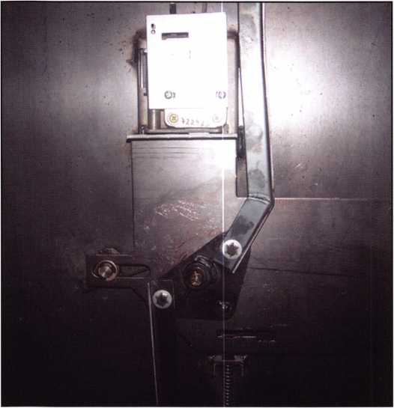

Keynotes • February 2006

**SUPER**

*SESAMEE*

Security Products

**A Division of The Eastern Company**

**301 West Hintz Road Wheeling, IL 60090 Telephone: 800.733.8588 Fax: 847.537.1881 [www.cclsecurity.com](http://www.cclsecurity.com)**

Features & Benefits

* Industrial Strength Combination Lock!
* Resists Hammer and Re-bar Attacks!
* Hardened Steel Full Metal Jacket!
* Hardened Steel Full Metal Jacket Shroud!
* Weather Resistant Black Electrocoating!
* 7/16” Chrome Plated Molybdenum Shackle!
* Inside Shackle Clearances: 1 ” and 2”!
* Shackle Pull Strength: 2,750 pounds!
* All Brass Inner Mechanism!
* Four All Brass Dials!
* 10,000 Changeable Combinations!
* Quick Delivery: Shipped from Stock!

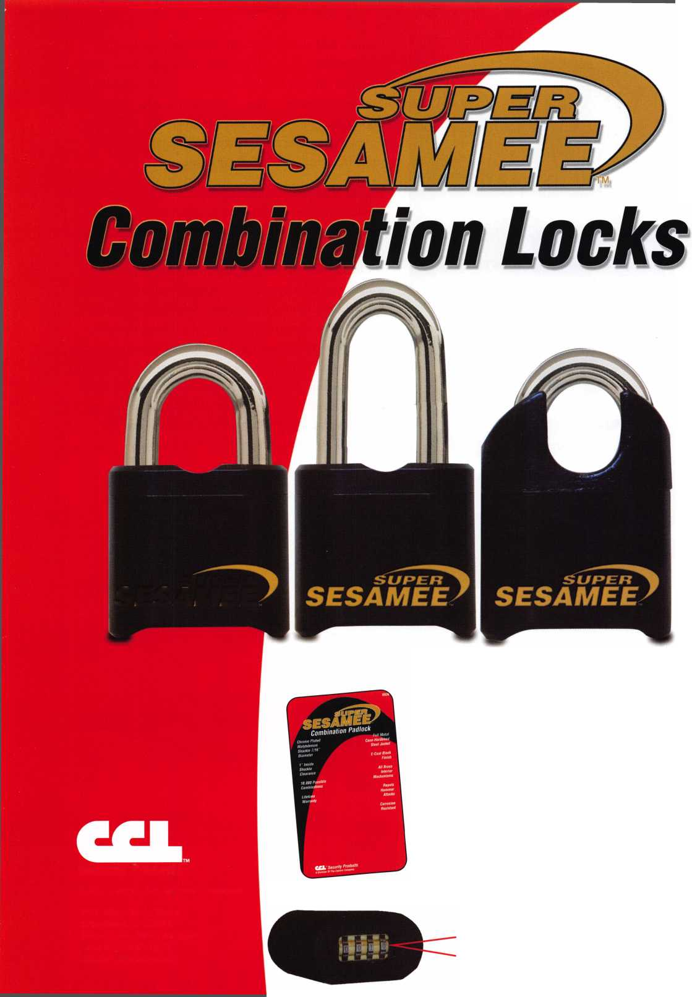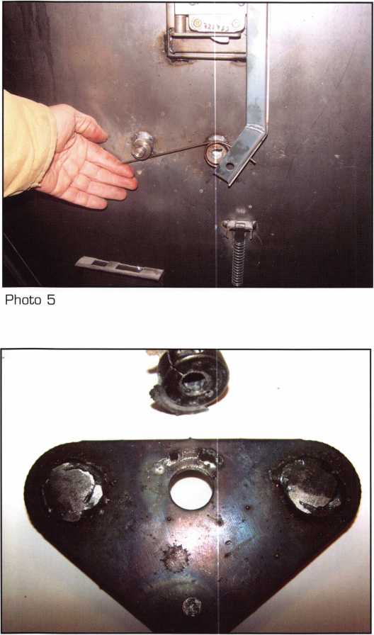

Photo B

Cannon had already sent out replacement parts so I installed them and took pictures and dimensions. The customer decided he wanted to repair it himself, although I offered to use taper pins. Welding the holes would have caused the paint to burn and we didn’t want to destroy the paint resulting in more repairs. The customer had some rubber plugs he planned to use.

I failed in my original plan of attack. If I had succeeded, I would have been a hero since the only damage would have been to easily replace the parts. I took far longer to get it open by trying to go through the handle shaft first. If I had drilled the side to push a bolt back, the safe would have been opened in a matter of minutes. Instead,

I spent a few hours. Was the time wasted? I think not. I learned more about the design of the safe and possible failure for future openings. I also learned to consider the combination of the short open time on an E-lock and the automatic bolt extension spring (seen in photo 5) when trying a handle/cam disconnect. Don’t be afraid to try something new and different. If it works, great. If it doesn’t, learn from your effort and move on.

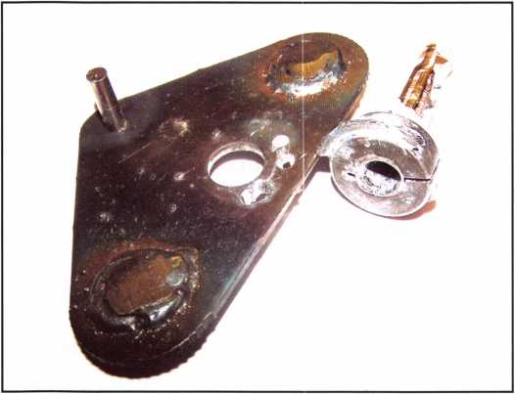

Photo 7



Keynotes • February 2006

Kaba Ilco Corp.

Hosts Modern Marvels

Kaba Ilco Corp, Rocky Mount North Carolina recently hosted  
a film crew taping segments for the Modern Marvels television  
series. The Modern Marvel series presents stories behind the  
innovations and technologies that have altered our way of life.

The program in which portions of Kaba Ilco manufacturing  
processes and products will be covered, is entitled Modern  
Marvels: More Hardware. From hammers to sandpaper and  
keys to pushbutton locks, the program will provide an enter-  
taining and educational overview of the hardware store and  
its evolution.

As more products are imported and independent business  
owners give rise to the larger retail stores, an American tradi-  
tion is still being preserved in North Carolina. Kaba Ilco Corp.  
located in Rocky Mount North Carolina, is the world s largest  
key blank, key machine and replacement lock cylinder manu-  
facturer. To the west, Kaba Access Controls, Winston-Salem,  
North Carolina is a leading innovator and manufacturer of  
mechanical and electrical commercial pushbutton combination  
locks that secure airports, government buildings, businesses  
and more.

Many people depend on American manufacturers and distrib-  
utors for jobs and livelihoods. Then there are those of us who  
still prefer to shop at an independently-owned and operated  
business. To be greeted by name when you walk through the  
door and have someone always ready to help you make a pur-  
chase. It’s an American tradition!

Chuck Murray, General Manager, Kaba Ilco Corp was the  
spokesperson for the factory production film segment.

The segment, shot in the Rocky Mount manufacturing facility,  
featured the manufacture of keys beginning with the produc-  
tion of brass through to the packing process. Tom Nazziola,  
Kaba Access Controls provided a segment on pushbutton locks

Modern Marvels: More Hardware aired on the History  
Channel, December 6, 2005 and will repeat. Check your local  
listings for the time and any possible schedule changes.

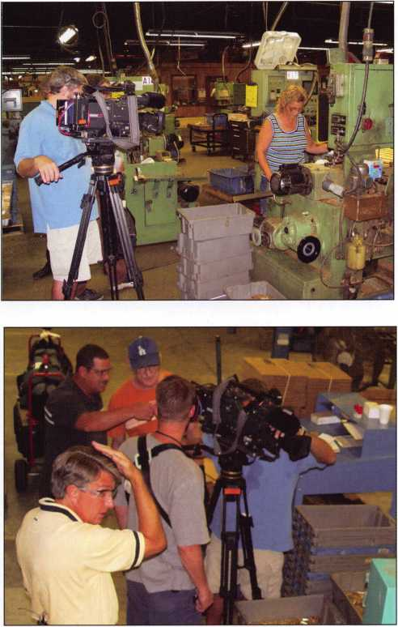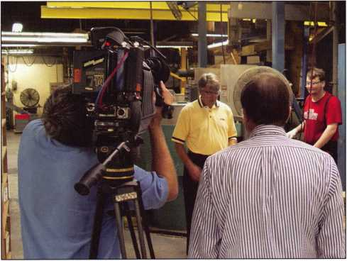

Security in Our Own Backyard

By: Claire L. Cohen, CML

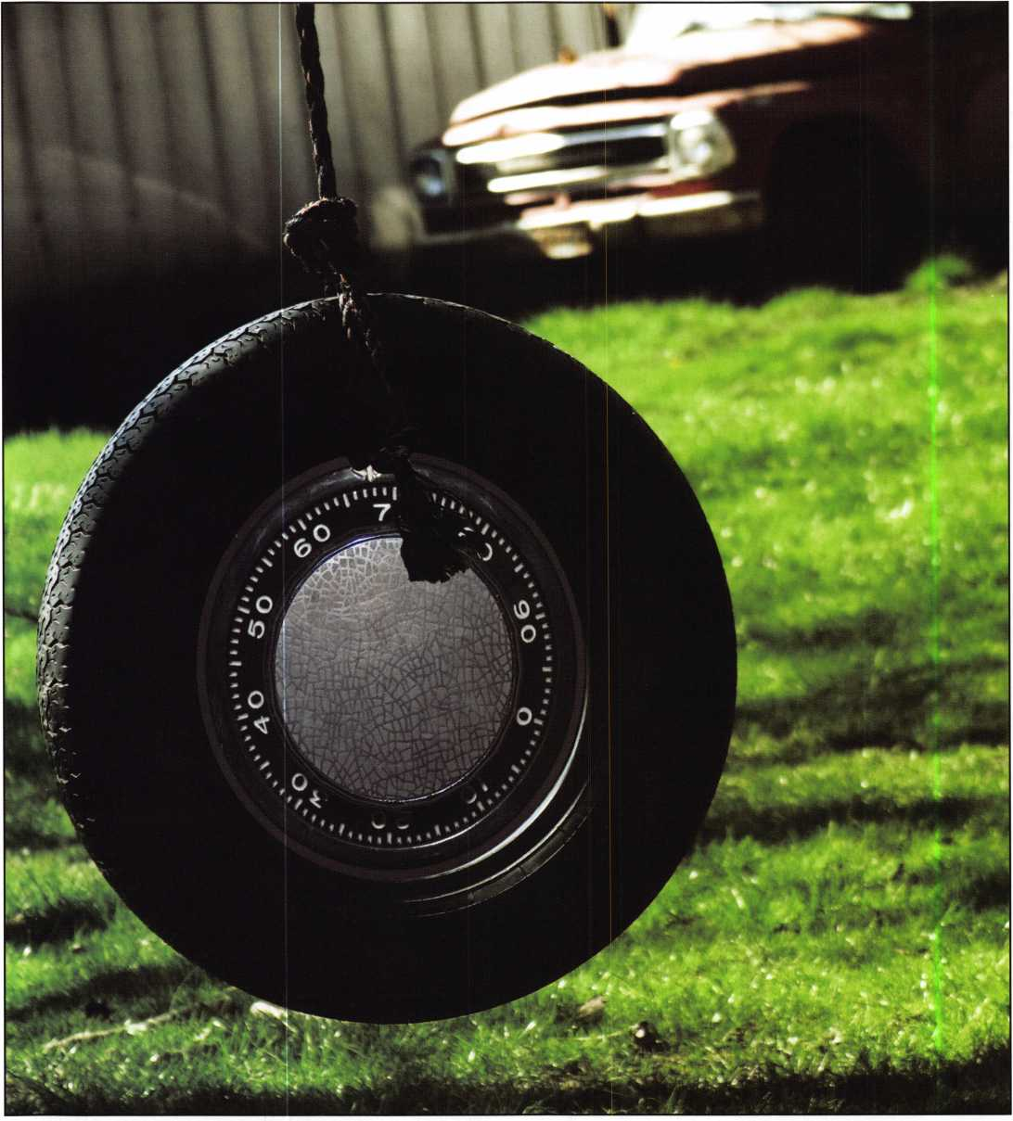

Keynotes • February 200B

We spend our days giving professional security advice to our customers, while sometimes overlooking the obvious— our own business establishment. It may be time to step back, and take a closer look at security right in our own backyard—our company. Whether your business is large or small, whether you have a retail location, a warehouse, or mobile service exclusively, it may be time to evaluate your security.

Small businesses are targets in over half the commercial burglaries committed. Most of these crimes occurred because someone left an “open door”— meaning that criminals are attracted by signs of carelessness. Crimes against business are usually crimes of opportunity. If you make it easy for someone to steal from you, chances are, someone will. So don’t make it easy. Make it risky and unrewarding.

There are several areas to examine when assessing your business security: physical security, shoplifting / loss pre­vention, and employee theft.

In your shop, follow the same advice that you would give your customer for physical security:

* Lock-up doors and windows
* Light up around all entrances
* Leave lights burning at night
* Clean up shrubbery from around window area
* Install alarm systems and test them regularly
* Post notices that you have an alarm system
* Keep cash to a minimum with frequent bank deposits
* Leave empty cash drawers open after hours
* Keep up-to-date and accurate inventory of merchan­dise and equipment both in retail establishments and on service vehicles

Shoplifting accounts for losses ranging from 2% to as much as 15% of sales nationally in unprotected shops.

Loss prevention should be part of training any member of your organization. Make sure all employees are trained to be attentive to customers and not easily distracted. Greet each shopper who enters. Let him know you are away of his/her presence.

Examine your store layout. Be visible. Arrange your count­er so that you will not turn your back on a customer.

Install phones where you can keep an eye on things.

Convex mirrors allow “blind spots” to be viewed from other parts of the shop. In a small shop with limited per­sonnel, it can be difficult to service a lock, look up a key code, or perform other locksmith-related services while maintaining an eye on the customer. Try not to work alone. But if you must, leave a radio or TV playing in the back room.

The very purpose of display and layout in a retail environ­ment is to create maximum customer desire.

Unfortunately, this objective often makes merchandise easi­ly accessible and attractive to shoplifters. It is a good mer­chandising technique to have attractive displays of impulse items such as key chains, padlocks, etc. available for cus­tomers to see while waiting for a lock to be repaired or a key to be made. However, proper attention to security must be maintained. Simple techniques, like limiting the rack height, or having only “samples” may deter a shoplifter. Arrange counters and displays so merchandise is in full view of employees. Keep easily removable merchan­dise protected, locked in counter cases whenever possible. Keep expensive items away from entrances.

Closed circuit television, CCTV has come into common use as an anti-shoplifting device. Customers should be made aware that CCTV is used. It may be desirable to post a sign such as: “This store is equipped with closed circuit television cameras.”

It is estimated that 30% of all business failures nationally result from employee dishonesty. It is incorrect to assume that the new employees alone may be the source of a busi­ness loss. Also, don’t take for granted the total honesty of longtime employees. They know the business inside and out, and are in a good position to be tempted. Inspire and reward honesty by creating the right working atmosphere.

Practice good security on the road as well as in the shop. Never leave service vehicles unattended, without being locked. Have you tested the vehicle alarm system lately?

Security starts in your own backyard! Use a proactive pre­vention approach to your own business, by assessing physi­cal security. Evaluate you store layout to minimize shoplift­ing. Train your employees in helping to prevent shoplift­ing, and reward honesty. Your business chain of security is only as strong as its weakest link.

Keynotes • February 2006

The Transition From Locksmith To Forensic Locksmith

By: Daniel E. Cunningham, JD, CRL, CFL, CFATE

The locksmithing profession has many different areas in which a person can specialize. Locksmiths can specialize in commercial work, residential or automotive. Each of these areas also have sub-areas in which a locksmith can specialize. The commercial locksmith can specialize in door hardware. The residential locksmith can specialize in apartment houses. And the automotive specialist can specialize in nothing but transponders, Fords, etc.

Most locksmiths are generalists and will work on anything that comes in the door. They will work in all areas; commer­cial, residential, and automotive. This gives most locksmiths a broad knowledge of locks and locking mechanisms. This var­ied knowledge is needed to become a forensic locksmith. However, not every locksmith, no matter how good they are, can qualify to be a forensic locksmith. As Dirty Harry said,

“A mans got to know his limitations!”.

Why cant an experienced locksmith, who has extensive lock- smithing knowledge become a good forensic locksmith? The answer lies in the qualifications that are required to become a forensic locksmith. Just because a person has been a locksmith for a number of years, it does not qualify him or her to spe­cialize in forensic locksmithing. Additional law enforcement training is required. The locksmith must receive additional training in evidence, report writing, photography, arson inves­tigation and courtroom testimony. However, it is easier to train a locksmith to learn the additional law enforcement skills necessary to be a forensic locksmith than it is to train a law enforcement officer to learn the necessary locksmith skills to be a forensic locksmith.

The investment in the required additional equipment can also be expensive. This includes equipment not normally found in a lock shop. Equipment such as a stereomicroscope, a trinocu- lar microscope and some high quality camera equipment will be required. A simple magnifying glass will not work. Like everything else, the world of the forensic locksmith has gone

high tech. Gone are the days when a locksmith could just look at a lock and, based upon a visual inspection, say whether or not a lock has been compromised.

The first step along the path to becoming a forensic locksmith is training. A person should have a solid background in locks and lock mechanisms, particularly in automotive lock­smithing. If the locksmith does not have this background he or shee needs to get educated to expand their knowledge before they even consider becoming a forensic locksmith. Automotive locksmithing is a must. Automotive investiga­tions are the bulk of assignments when doing work for insurance companies.

The next step is basic training as a forensic locksmith. Currently, the only course that really covers the necessary areas is “Investigative Locksmithing”, offered by the International Association Of Investigative Locksmiths. It is an intensive three-day course that covers the basic aspects of forensic locksmithing. The course covers such subjects as the preservation of a crime scene and crime scene documentation; detailed report writing; the identification, collection and preservation of evidence and the “chain of evidence”; both macro and microphotography; basic legal requirements for an “expert” witness; how to develop a “CV” (Curriculum Vite); and extensive hands-on examination of locks, pins and wafers.

The basic course is just the start. Once the basic course is complete the locksmith must receive additional training in the area(s) of forensic locksmithing in which they plan to work. If their specific area is going to be automotive, they will need training in vehicle arson investigations and recovery of locks and locking mechanisms. They need to learn auto theft methods and security system bypass techniques and how to recognize them, even though the car might be burnt almost beyond recognition. Additional training is required in insur­ance fraud investigations, transponder technology, metallurgy, and lock and key microscopic analysis.

**30**

Keynotes • February 2006

Part #692931 ' ^

**INNOVATIVE DESIGN**

The offset position of the transponder in the head of the key maximizes the RFID signal strength by placing it closer to the ignition signal.

Part #708884

CODE-5EEKER

0®d)

®@®

®®®

®O0

®®0

RATION

h

STRATTEC'

TRUSTED SOURCE. MANY SOLUTIONS.

**Now** Available

2006 GENERAL MOTORS TRANSPONDER KEYS

**CUTTING EDGE TECHNOLOGY**

Designed to transmit a stronger RFID signal for better overall performance

General Motors Trademarks are used under license to STRATTEC Security Corporation

**MING SOON!** CADILLAC, PONTIAC AND BUICK VERSIONS.

**CODE-SEEKER ™**

NOT JUST A TOOL, A MONEY-MAKING MACHINE.

FEATURE-FILLED!

* Easy to use, quickly connecting to the OBD port
* Includes all cables and connectors

Adds, erases and programs keys Program RKE fobs (selected models)

* Obtains immobilizer code for certain models
* Fully upgradeable

Expandable database

ORDER YOUR MONEY-MAKING MACHINE TODAY.

Leasing Options Available. Contact your local distributor today,

3333 WEST GOOD HOPE ROAD MILWAUKEE, Wl 53209 877.251.8798

<http://aftermarket.strattec.com>

©2005 STRATTEC SECURITY CORPORATION. ALL RIGHTS RESERVED.

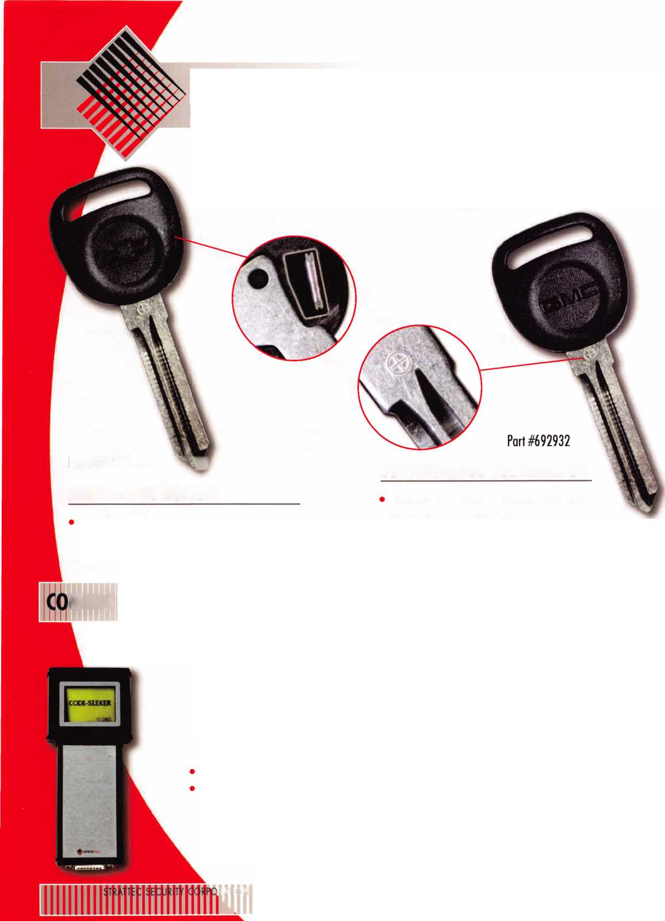

Once all this training is complete, the most important thing for the locksmith is a shift in thinking. A locksmith is trained to diagnose problems with locks and repair them, with the least possible damage to the lock and surrounding hardware. This applies to both commercial and automotive. A successful forensic locksmith MUST learn to think like a thief. They must learn to view a lock like a thief by asking the question, “How am I going to defeat or bypass this?”

Why does a locksmith need to think like the thief? The rea­son is very simple. Many thefts do not involve attacking the lock itself. This is particularly true in automobile thefts. If you think like a thief and not a locksmith you will know where to look for evidence of how a lock was bypassed or defeated. If you think like a locksmith you will never find a lot of evidence.

A good example of can be seen in the Saginaw round column used in General Motors cars. When “tearing down” a column to replace a lock cylinder the locksmith tears it down only far enough to remove the retaining screw that holds the lock cylinder in place. This allows the lock cylinder to be removed and replaced. They never disassemble the upper “bowl” which houses the sector gear and sector spring. Many locksmiths don’t even know where or what these parts are or how they function in the operation of the column. The auto thief knows. This is where a thief will attack a Saginaw round col­umn. They break the bowl, pry out the sector gear and start the car. They don’t even touch the lock.

How would a theif defeat a vehicle with a VATS security sys­tem or a Ford with a transponder security system? A lock­smith knows how to cut the proper key for these units and how to program in a new key for a transponder system, but how many of them know how to bypass the VATS or transponder system? Do they know what to look for in an investigation? Most don’t.

The locksmith still has to get hands-on experience. One way to do this to make frequent trips out to the junkyard.

Another method is to make friends with a car dealer who will let you gain experience on new and used cars. Using the new and used cars you can learn how to bypass electronic vehicle security systems. At the junkyard, the locksmith learns how to attack a steering column in the same manner as a car thief.

A car thief does not take the time to orderly disassemble a steering column or a security system. The thief will destroy

parts or anything else he needs to destroy to quickly steal the car. If the locksmith has a good working relationship with the local police department, he might be able to examine recov­ered stolen cars.

The locksmith then needs to prepare a “CV” and some “sam­ple” reports. The “CV” is similar to a resume in which the locksmith lists all his education, training and achievements. If a locksmith does not have any jobs, a sample report can be made as an example of the quality of their work.

Many junkyards have one or two vehicles that were reported as stolen at one time or another. These vehicles can be studied. (Many times, because of the liens and storage fees against the vehicles the junkyard ends up owning the vehicle.) An alter­native is to have someone go into a vehicle and attack it as though they were trying to steal it.

Once the vehicle is selected, the locksmith can approach it and treat the study like an actual investigation. The locksmith should take photos of the vehicle, the locks and any related components; keep notes of the investigation and remove the locks as necessary. Treat the “investigation” exactly like the real thing. Once the locksmith returns to the shop take the locks apart and examine them, taking close-up photos and microscopic photos is required. The locksmith must then write a “report” of their investigation and findings. Be sure to write “SAMPLE REPORT” on the report.

Now armed with a CV and a few sample reports, the lock­smith needs to go out and make themselves known to poten­tial clients. Potential clients can include insurance company SIU investigators, police detectives, attorneys or anyone else that might use their services. Take the time to explain to the potential client WHAT YOU CAN DO FOR THEM. Don’t “blow your own horn” but let the client know what is in it for them to use your services. Once they become aware of you and what you can do for them you will begin to get clients and your business will grow.

**32**

Keynotes • February 2006

Starting Over with Your Help

ALOA has recently received information from  
ALOA member survivors of Hurricanes Rita and  
Katrina that much of their livelihoods were washed  
away in the storm. Those who have finally been  
able to return to their Locksmith businesses, (the  
few that were still standing) found that their key  
machines, if not swept away, had been submerged  
under water for weeks and were rendered a total  
loss. Most hand tools and locksmithing materials  
have been washed away. Some of your fellow mem-  
bers have lost everything.

Now, I know that everyone from large charities to  
Little League baseball teams have come knocking  
on your door asking you for some form of donation  
(usually cash) to support their programs.

Sometimes it seems like everybody wants something  
from you but this hits the heart of our industry and  
brings the tragedy close to home. ALOA is looking  
for something from you now, but it's not cash or a  
check.

Can you help our affected members start over  
through donations of key machines and tools?

If you have any unused key machines (in good  
working condition) please donate them to ALOA  
members who can really use them. Everyone has a  
few extras lying around. How about the key  
machine you put in the back of the shop and never  
use? Or maybe you have an extra pinning kit or  
some hand tools you're not using. Now is the time  
to help out if you can.

ALOA has compiled a list of items lost to storms

Rita & Katrina. This list will be posted online and is only a small sample of what is needed: tools, equipment, key machines,  
code books, key blanks, and materials such as deadbolts, locksets to name a few of the items.

If you can part with any Locksmith items (in working order only), please consider donating them to your fellow ALOA Locksmiths in need. ALOA will gather up all incoming donations and get them to those in need.

Please send all donations to: ALOA Starting Over, 3500 Easy Street, Dallas Texas 75247

If you have any questions, please contact:

David Lowell, CML, CMST (214) 819-9733 ext 101 [david@aloa.org](mailto:david@aloa.org) Robert Stafford, CML (214) 819-9733 ext 102 [Bob@aloa.org](mailto:Bob@aloa.org)

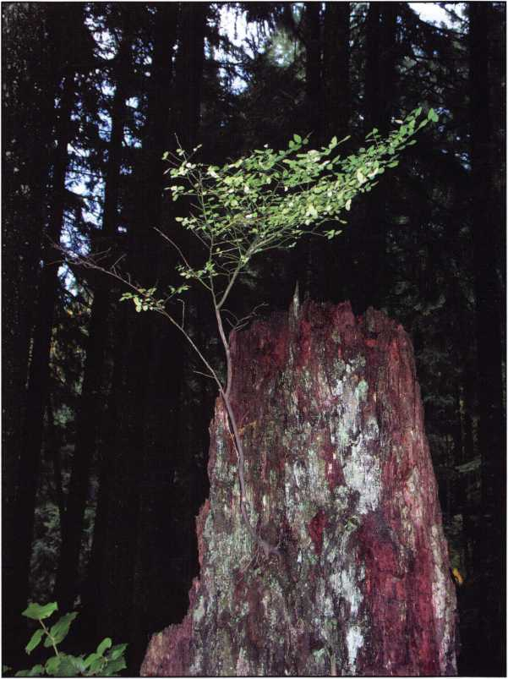

A new tree is starting to grow from it’s grandfather.

Keynotes • February 2006

**Email: [glmperry@imuisp.com](mailto:glmperry@imuisp.com) for unlock code Greg Perry 2003**

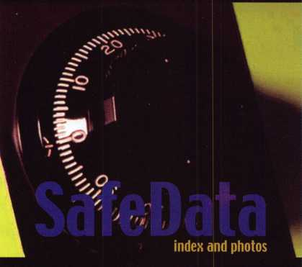

SafeData

Greg Perry, CML, CPS

Open up your library! SafeData allows you to find the information you've  
invested in, fast.This one program has over 8500 listings of magazine, books,  
ClearStar Security Network posts and my personal library. Each listing includes not  
only the book or magazine, the issue, the title, the author and the page, but it also  
lists the lock and the hand of the lock (when available). SafeData lists patent dates  
and other trivia that may help in identifying a container or lock.

SafeData also has picture folders representing over 90 different manufactures of  
safes and locks with over a thousand pictures. Some models include a text file giv-  
ing general information on size and relock locations. Plus you can add your own  
information and update it yourself or purchase the annual updates.

SafeData is available exclusively from ALOA. Normal price for this CD is $249.95.  
Price includes two installs! Put it on your desktop and your laptop.

Special Introductory offer

includes your first update!

**$**199.95

To order contact ALOA (800) 532-2562

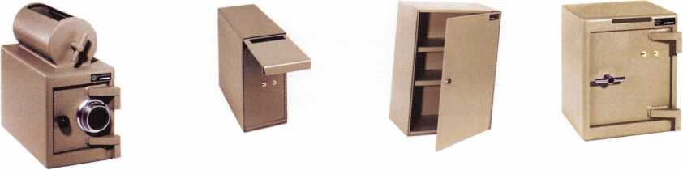

A & B Safe Corporation

Manufacturers of Quality Depository Safes & Chests

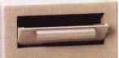

114 South Delsea Dr. Suite 3  
Glassboro, NJ 08028

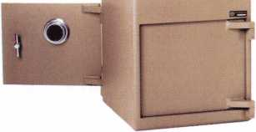

800-253-1267 Fax 856-863-1208

[info@a-bsafecorp.com](mailto:info@a-bsafecorp.com)

[www.a-bsafecorp.com](http://www.a-bsafecorp.com)

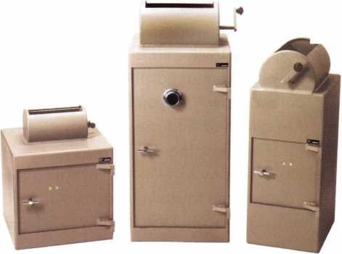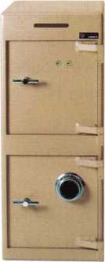

Over Seventy-Five Models In Stock

**Classifieds**

EMPLOYMENT

LIVE, WORK & PLAY IN HAWAII

Locksmith Service Technician needed for 25-year-old compa­ny in HAWAII. Need knowledge and experience in all areas of locksmithing. Wages commensu­rate with experience and abili­ties. Great health and dental insurance and benefits. Late model van and tools provided. Mail resume to: Paradise Lock & Safe, 350 Ward Ave., Suite 106-417, Honolulu, HI. 96814-4004.

EXPERIENCED LOCKSMITH WANTED

Charlottesville, VA is seeking an experienced locksmith. For infor­mation, please

e-mail: [snowderrow@aol.com](mailto:snowderrow@aol.com) or fax resume to 434-971-8021. Phone 434-977-5397.

EXPERIENCED LOCKSMITH WANTED

Nationwide Security & Building Services, Inc. (NSBS) has been in business for over 30 years and is an established leader in the security industry. In addition to providing all aspects of lock­smith and security services, we

also provide complete facility maintenance. We are in need of experienced and motivated lock­smiths who take pride in their work. We currently have an opening for a locksmith techni­cian working out of our Downey, CA, San Diego, CA, Phoenix, AZ and Irving, TX loca­tions. A qualified candidate must have minimum 2 years commercial locksmith experi­ence, excellent communication skills, a good driving record and some computer skills. Safe opening, skills in electrical, light­ing, drywall, doors and gates are a plus. Benefits of being employed by NSBS include: paid vacation / holidays, med­ical, dental and life insurance, competitive wages, 401k plan, company truck and all tools are supplied, fun atmosphere with career growth. If you feel you are qualified and are looking for a challenging and reward­ing company to work for, e-mail your resume to [dawnu@nsbs.net](mailto:dawnu@nsbs.net) or fax to (562) 299-1511.

WANTED

BVI, Inc., a Red Hawk Industries Company is seeking several exp. F/T Field Service Techs in MD, DC and VA. Must be exp. in physical and electronic securi­ty systems, or gen. bank equip­ment. Must have 3 + years exp. clean driving record, and pass a drug test. Excellent comp, and benefits pkg. inch company vehicle. Forward resume with salary history to:

Resumes. [PA@redhawkindus- tries.com](mailto:PA@redhawkindus-tries.com) or fax to Linda Foggie at 215-396-8799.

WANTED TO BUY/SELL

FOR SALE

One Collier night depository self encased in steel, like new. TL15 Chest and UL Head with 25 keys - $3500.00. One class two vault door in good condition - $2500.00. One used 1073 diebold drive up ATM - make an offer. Many used safes please call for sizes and prices. Buyer pays for crating and freight. Contact: Thistle Safe and Lock Co., Inc., 198 Cross St.,

Malden, MA 02148, 781-324- 1600, [thistlesnl@aol.com](mailto:thistlesnl@aol.com)

NORTHERN CA BUSINESS FOR SALE

You now have the unique oppor­tunity to purchase an estab­lished lock and safe business (1958) and clientele in a fast growing college town (Chico, CA), and possibly the plaza that houses the shop. Owner is look­ing to retire and owns both. We have great licensed employees, three vans, and a fully stocked shop. Please fax your references and letter of interest to: Johnny's Lock & Safe 530-873-3577.

FOR SALE

Framon II code machine, never used. Asking $1,500.00. Telephone: 610-698-8040, Email: [Foxlocknkey@aol.com](mailto:Foxlocknkey@aol.com)

MOBILE LOCKSMITH BUSINESS FOR SALE

Central California Locksmith Business established in 1999 and still growing. Includes van, tools, equipment, code machine, inventory. Commercial, residen­tial and automotive accounts. Located in Fresno, CA.

$50,000. Ask for Noa Kristi 559-447-5397

KEY MACHINES FOR SALE

HPC 1200, Abloy, KD-55 High Security, Fitmaster, Curtis Automatic #2000, Scotsman #747-X, Sager #500, Borkey #954-2, llco Duplicon #2585, Keil #6 1/2, Segal #815, Belsaw, 2 Schlage double-sided key punches. Phone Jerry at 208-461-4606 or email: [mariemeilan@yc2.net](mailto:mariemeilan@yc2.net)

NEW LOCKSMITH SHOP FOR SALE

Leased store front shop. Would like to retire due to health. Next to NASA Bay Space Center, on a very busy highway. Covering three counties. Over $70,000 plus in equipment and inventory. Fully equipped van. Asking $55,000, will consider all reasonable offers. Email if interested

[www.fgarza](http://www.fgarza) [1948@yahoo.com](mailto:1948@yahoo.com) or fax 281-488-0883.

BUSINESS FOR SALE

Ideal business for 1 person or easily expand business. Established 1997 - mostly com­mercial and residential. Repeat and referral business with $0 paid advertising, close proximity

accounts (about 8K miles per year), bankers hours (M-F 9-5, Sat 9-3). Shop equipment, tools and inventory, 2003 truck (less than 50K miles) with equipment, tools, and inventory. Deal on shop lease if desired or run as a mobile business. Asking $150K - annual gross sales over 100K - annual net profit well over 50K. Located in Houston, TX. Call Ron 281-660-3000.

Classified Advertising Policy

Classified advertising space is provided free of charge to ALOA members and for a fee of $2.00 per word, $40.00 minimum for non members. Classified ads may be used to advertise used merchandise and overstocked items for sale, "wanted to buy" items, business opportunities, employment opportunities/positions wanted and the like. Members or non members wishing to advertise services or new merchandise for sale may purchase a "Commercial Classified Ad" for a fee of $4.00 per word with a minimum of $100.00. Each ad will run for two issues. For blind boxes there is a $10.00 charge for members and non members. All ads must be submitted in writing to the Advertising Sales Department via fax at 817-645-7599 or through an email to [adsales@aloa.org](mailto:adsales@aloa.org) by the fifteenth of the month two months prior to issue date. ALOA reserves the right to refuse any classified adver­tisement that it deems inappropriate according to the stated purpose of the classified advertising section.



associate

members

Distributor

**1st In Hardware, Inc.**

Phone: Phone: 410-646-9900 Fax: 410-646-0045 www. 1 stinhardware.com

**Accredited Lock Supply Co.**

Phone: 800-652-2835 Fax: 201-865-0030 [www.acclock.com](http://www.acclock.com)

**Andrews Wholesale Lock Supply**

Phone: 717-272-7422 Fax: 717-274-8659 [www.andrewslock.com](http://www.andrewslock.com)

**Boyle & Chase Inc.**

Phone: 800-325-2530 Fax: 800-205-3500 [www.boyleandchase.com](http://www.boyleandchase.com)

**Clark Security Products**

Phone: 888-784-1311 Fax: 619-718-7333 [www.clarksecurity.com](http://www.clarksecurity.com)

**CookAs Building Specialties**

Phone: 505-883-5701 Fax: 505-883-5704

**Dire's Lock & Key Company**

Phone: 303-294-0176 Fax: 303-294-0198

**Direct Security Supply, Inc.**

Phone: 800-252-5757 Fax: 800-452-8600

**Discount Key Machines.Com/Busch**

Phone: 800-332-8724 Fax: 407-363-4666

**Doyle Security Products**

Phone: 800-333-6953 Fax: 612-521-0166 [www.doylesecurity.com](http://www.doylesecurity.com)

**Dugmore and Duncan, Inc.**

Phone: 888-384-6673 Fax: 888-329-3846

**E. L. Reinhardt Co., Inc.**

Phone: 800-328-131 1 Fax: 651-481-0166 [www.elreinhardt.com](http://www.elreinhardt.com)

**Ewert Wholesale Hardware**

Phone: 800-451-0200 Fax: 708-597-0881

**Foiey-Belsaw Company**

Phone: 800-821-3452 Fax: 816-483-5010 [www.foley-belsaw.com](http://www.foley-belsaw.com)

**Fried Brothers Inc.**

Phone: 800-523-2924 Fax: 215-592-1255 [www.fbisecurity.com](http://www.fbisecurity.com)

**Hans Johnsen Company**

Phone: 214-879-1550 Fax: 214-879-1530 [www.hjc.com](http://www.hjc.com)

**Hardware Agencies, Ltd.**

Phone: 416-462-1921 Fax: 416-462-1922 [www.hardwareagencies.com](http://www.hardwareagencies.com)

**IDN Incorporated**

Phone: 817-421-5470 Fax: 817-421-5468 [www.idn-inc.com](http://www.idn-inc.com)

**Instant Hardware Delivery, Inc**

Phone: 800-355-1107 Fax: 800-663-8518

**Intermountain Lock & Supply**

Phone: 800-453-5386 Fax: 801-485-7205 [www.intermountainlock.com](http://www.intermountainlock.com)

**International Electronics, Inc**

Phone: 800-343-9502 Fax: 617-821-4443

**Jo Van Distributors**

Phone: 416-288-6306 Fax: 416-752-8371 [www.jovanlock.com](http://www.jovanlock.com)

**Lockmasters, Inc.**

Phone: 859-885-6041 Fax: 859-885-7093 [www.lockmasters.com](http://www.lockmasters.com)

**Locks Company**

Phone: 800-288-0801 Fax: 305-949-3619

**Locksmith Ledger International**

Phone: 770-886-0800 Fax: 770-889-7703 [www.lledger.com](http://www.lledger.com)

**McDonald Dash Locksmith Supply**

Phone: 800-238-7541 Fax: 901-366-0005 [www.mcdonalddash.com](http://www.mcdonalddash.com)

**Monaco Lock Co.**

Phone: 800-526-6094 Fax: 800-845-5625 [www.monacolock.com](http://www.monacolock.com)

**Omaha Wholesale Hardware**

Phone: 800-238-4566 Fax: 402-444-1664 [www.omahawh.com](http://www.omahawh.com)

**Phoenix Safe International LLC**

Phone: 765-483-0954 Fax: 765-483-0962 [www.phoenixsafeusa.com](http://www.phoenixsafeusa.com)

**RA-Lock Company**

Phone: 972-775-6301 Fax: 972-775-6316 [www.ralock.com](http://www.ralock.com)

**Security Distributors Inc**

Phone: 800-333-6953 Fax: 612-524-0166

**Security House**

Phone: 905-669-5300 Fax: 905-660-6313 [www.securityhouselock.com](http://www.securityhouselock.com)

**Security Lock Distributors**

Phone: 800-847-5625

Fax: 800-878-6400

[www.securitylockdistributors.com](http://www.securitylockdistributors.com)

**Southern Lock and Supply Co.**

Phone: 727-541-5536 Fax: 727-544-8278 [www.southernlock.com](http://www.southernlock.com)

**Stone & Berg Wholesale**

Phone: 800-225-7405 Fax: 800-535-5625

**The Locksmith Store Inc.**

Phone: 847-364-5111 Fax: 847-364-5125 [www.locksmithstore.com](http://www.locksmithstore.com)

**Timemaster Inc.**

Phone: 859-259-1878 Fax: 859-255-0298 [www.time-master.com](http://www.time-master.com)

**Top Notch Distributors, Inc.**

Phone: 800-233-4210 Fax: 800-854-4146 [www.topnotch.bz](http://www.topnotch.bz)

**Turn 10 Wholesale**

Phone: 800-848-9790 Fax: 800-391-4553

**U.S. Lock Corp.**

Phone: 800-925-5000 Fax: 800-338-5625 [www.uslock.com](http://www.uslock.com)

**Wilson Safe Company**

Phone: 215-492-7100 Fax: 215-492-7104 [www.wilsonsafe.com](http://www.wilsonsafe.com)

Manufacturer

**A & B Safe Corporation**

Phone: 800-253-1267 Fax: 856-863-1208 [www.a-bsafecorp.com](http://www.a-bsafecorp.com)

**ABUS Lock Company**

Phone: 800-352-2287 Fax: 602-516-9934 [www.abus.com](http://www.abus.com)

**Access Security Products Ltd.**

Phone: 905-337-7874 Fax: 905-337-7873 [www.access-safe.com](http://www.access-safe.com)

**Adams Rite Mfg Company**

Phone: 800-872-3267 Fax: 800-232-7329 [www.adamsrite.com](http://www.adamsrite.com)

**Adesco Safe Mfg. Company**

Phone: 800-694-9340 Fax: 562-408-6427 [www.adesco.com](http://www.adesco.com)

**Adrian Steel Company**

Phone: 800-677-2726 Fax: 517-265-5834 [www.adriansteel.com](http://www.adriansteel.com)

**Advanced Diagnostics USA Inc**

Phone: 650-876-2020 Fax: 650-876-2022 [www.ad-mvp.com](http://www.ad-mvp.com)

**All Five Tool Company, Inc.**

Phone: 860-583-1691 Fax: 860-583-4516 [www.all5tool.com](http://www.all5tool.com)

**American Security Products**

Phone: 909-685-9680x2013 Fax: 909-685-9685 [www.amsecusa.com](http://www.amsecusa.com)

**BWD Lockcraft**

Phone: 973-728-3707 Fax: 973-728-3731 [www.bwdautomotive.com](http://www.bwdautomotive.com)

**Bianchi USA, Inc.**

Phone: 800-891-2118 Fax: 216-803-0202

**Buddy Products**

Phone: 312-733-6400 Fax: 312-733-8356 [www.buddyproducts.com](http://www.buddyproducts.com)

**CCL Security Products**

Phone: 800-733-8588 Fax: 847-537-1800 [www.cclsecurity.com](http://www.cclsecurity.com)

Keynotes • February 2006



**CompX Security Products**

Phone: 864-297-6655 Fax: 864-297-9987 [www.compxnet.com](http://www.compxnet.com)

**D&D Technologies (USA), Inc.**

Phone: 714-677-1300x292 Fax: 714-677-1299 [www.ddtechusa.com](http://www.ddtechusa.com)

**DETEX Corp.**

Phone: 800-729-3839 Fax: 830-620-6711 [www.detex.com](http://www.detex.com)

**Don-Jo Manufacturing, Inc.**

Phone: 978-422-3213 Fax: 978-422-3467 [www.don-jo.com](http://www.don-jo.com)

**Door Controls International**

Phone: 800-742-3634 Fax: 800-742-0410 [www.doorcontrols.com](http://www.doorcontrols.com)

**Doorking Inc.**

Phone: 800-826-7493 Fax: 310-641-1586 [www.doorki](http://www.doorki) ng .com

**FireKing Security Products**

Phone: 800-457-2424 Fax: 800-896-6606 [www.fkisecuritygroup.com](http://www.fkisecuritygroup.com)

**Framon Manufacturing Company Inc.**

Phone: 989-354-5623 Fax: 989-354-4238 [www.framon.com](http://www.framon.com)

**HY-KO Products Co.**

Phone: 330-467-7446 Fax: 330-467-7442

**Hammerhead Industries, Inc.**

Phone: 805-658-9922 Fax: 805-658-8833 [www.gearkeeper.com](http://www.gearkeeper.com)

**Ingersoll Rand Security Technologies**

Phone: 800-847-1864 Fax: 800-366-5625 [www.schlagelock.com](http://www.schlagelock.com)

**Jackson Corporation**

Phone: 323-269-811 1 Fax: 800-888-6855 [www.jacksonexit.com](http://www.jacksonexit.com)

**Jet Hardware Mfg., Co.**

Phone: 718-257-9600 Fax: 718-257-0973 [www.jetkeys.com](http://www.jetkeys.com)

**KABA ILCO Corp.**

Phone: 252-446-3321 Fax: 252-446-4702 [www.kaba-ilco.com](http://www.kaba-ilco.com)

**KEY-BAK/West Coast Chain Mfg.**

Phone: 909-923-7800 Fax: 909-923-0024 [www.keybak.com](http://www.keybak.com)

**Keri Systems Inc.**

Phone: 408-451-2520 Fax: 408-441-0309 [www.kerisys.com](http://www.kerisys.com)

**Knaack Manufacturing Co.**

Phone: 800-456-7865 Fax: 815-459-9097 [www.weatherguard.com](http://www.weatherguard.com)

**LAB Security**

Phone: 800-243-8242 Fax: 860-583-7838 [www.labpins.com](http://www.labpins.com)

**La Gard Inc.**

Phone: 310-325-5670 Fax: 310-325-5615 [www.lagard.com](http://www.lagard.com)

**Lock America, Inc. dba L.A.I. Group**

Phone: 714-373-2993 Fax: 714-373-2998 [www.laigroup.com](http://www.laigroup.com)

**Lucky Line Products, Inc.**

Phone: 858-549-6699 Fax: 858-549-0949 [www.luckyline.com](http://www.luckyline.com)

**M.A.G. Manufacturing**

Phone: 714-891-5100 Fax: 714-892-6845 [www.magmanufacturing.com](http://www.magmanufacturing.com)

**MUL-T-LOCK USA, Inc.**

Phone: 800-562-3511 Fax: 973-778-4007 [www.mul-t-lockusa.com](http://www.mul-t-lockusa.com)

**Major Mfg, Inc.**

Phone: 714-772-5202 Fax: 714-772-2302 [www.majormfg.com](http://www.majormfg.com)

**Maxcess Card Systems Ltd**

Phone: 949-492-5964 Fax: 949-492-0415 www. maxcess-card .com

**Medeco Security Locks**

Phone: 540-380-5000 Fax: 540-380-5010 [www.medeco.com](http://www.medeco.com)

**Mil-Comm Products Co Inc**

Phone: 201-935-8561 Fax: 201-935-6059

**Protex Safe Co., LLC**

Phone: 818-610-8030 Fax: 818-610-8004 [www.protexsafe.com](http://www.protexsafe.com)

**ROFU International Corp.**

Phone: 253-922-1828 Fax: 253-922-1728 [www.rofu.com](http://www.rofu.com)

**Rutherford Controls Int'l Co.**

Phone: 519-621-7651 Fax: 519-621-7939 [www.rutherfordcontrols.com](http://www.rutherfordcontrols.com)

**STRATTEC Security Corp.**

Phone: 414-247-3333

Fax:414-247-3564

[www.aftermarket.strattec.com](http://www.aftermarket.strattec.com)

**Sargent & Greenleaf, Inc.**

Phone: 859-885-9411 Fax: 859-885-3063 [www.sargentandgreenleaf.com](http://www.sargentandgreenleaf.com)

**Sargent Manufacturing Co.**

Phone: 800-727-5477 Fax: 888-863-5054 [www.sargentlock.com](http://www.sargentlock.com)

**Schwab Corp.**

Phone: 765-447-9470 Fax: 765-447-8278 [www.schwabcorp.com](http://www.schwabcorp.com)

**Securifort Inc**

Phone: 819-359-2226 Fax: 819-359-2218 [www.securifort.com](http://www.securifort.com)

**Securitron Magnalock Corp.**

Phone: 775-355-5625 Fax: 775-355-5636 [www.securitron.com](http://www.securitron.com)

**Security Door Controls**

Phone: 805-494-0622 Fax: 805-494-8861 [www.sdcsecurity.com](http://www.sdcsecurity.com)

**Security Solutions**

Phone: 405-376-1600 Fax: 405-376-6870 [www.securitysolutions-usa.com](http://www.securitysolutions-usa.com)

**Sun Safes Manufacturing Co.**

Phone: 823-194-5930 Phone: 823-194-5940

**Town steel, Inc.**

Phone: 626-858-5080 Fax: 626-858-3393 [www.townsteel.com](http://www.townsteel.com)

**UCA Inc**

Phone: 972-312-0599x12 Fax: 972-692-7056 [www.ibuttonlock.com](http://www.ibuttonlock.com)

**Ultra Lift Corporation**

Phone: 800-346-3057 Fax: 408-297-1199 [www.ultralift.com](http://www.ultralift.com)

**Videx Inc.**

Phone: 541-758-0521 Fax: 541-752-5285 [www.videx.com](http://www.videx.com)

**YSG Door Security Consultants, Inc.**

Phone: 800-438-1951 Fax: 800-338-0965

Service

Organization

**Allstate Insurance Company**

Phone: 800-859-0247 Fax: 847-551-2786 [www.allstate.com](http://www.allstate.com)

**Cardservice Mobile Solutions**

Phone: 561-210-8488 Fax: 561-953-6268

[www.cardservicems.com](http://www.cardservicems.com)

**Cross Country Automotive Services**

Phone: 800-541-2262 Fax: 781-393-0256 [www.argosi.com](http://www.argosi.com)

**Massglass & Door Service**

Phone: 888-742-8837 Fax: 805-497-2255 [www.massglass.com](http://www.massglass.com)

**The Mechanic Group Inc**

Phone: 845-735-0700 Fax: 845-735-8383 [www.mechanicgroup.com](http://www.mechanicgroup.com)

**Webster Safe & Lock Co., Inc.**

Phone: 901-332-2911 Fax: 901-332-2878 [www.webstersinc.com](http://www.webstersinc.com)

Keynotes • February 2006



CA A 714

AUTHOR: Ridley-Thomas (D) TITLE: Motor Vehicles: Key Information Access INTRODUCED:

02/17/2005 LAST AMEND:

09/08/2005 DISPOSITION: Pending - Carryover

LOCATION: Assembly Transportation Committee SUMMARY: Requires every motor vehicle manufacturer of a motor vehicle sold or leased in this state with a model year of 2007 or later to provide a means whereby the registered owner of that motor vehicle can access information sufficient to permit the reproduction of a key to operate the owner's vehicle 24 hours each day and 7 days each week.

STATUS:

* 02/17/2005 INTRODUCED.
* 09/07/2005 To ASSEMBLY Committees on TRANSPORTA­TION and BUSINESS AND PROFESSIONS.
* 09/08/2005 From ASSEM­BLY Committee on TRANS­PORTATION with author's

r‘l*

amendments.

* 09/08/2005 In ASSEMBLY. Read second time and amended. Re-referred to Committee on TRANSPORTA­TION.

IA HSB 507

AUTHOR: House Judiciary Committee TITLE: Locksmith DISPOSITION: Pending SUMMARY:

Relates to a locksmith assisting a person in entering a residen­cy and providing a penalty. STATUS:

* 01/10/2006 INTRODUCED.
* 01/10/2006 To HOUSE Committee on JUDICIARY.

IL H 4715

SPONSOR: Kelly (D)

TITLE: Safe Homes Act INTRODUCED:

01/13/2005 DISPOSITION: Pending SUMMARY: Creates the Safe Homes Act. Provides that a vic­tim of domestic violence or sex­ual violence has certain rights with respect to the victim's dwelling unit. Provides that,

depending upon the circum­stances, the victim can obtain relief that includes: requiring that the landlord change the locks, allowing the victim to change the locks if the landlord does not act, terminating the lease, and imposing penalties on a landlord for certain viola­tions.

STATUS:

* 01/12/2006 INTRODUCED.
* 01/12/2006 To HOUSE Committee on RULES.

MD H 50

AUTHOR: Goodwin (D)

TITLE: Business Income Tax Exemption for Security DISPOSITION: Pending SUMMARY: Allows certain busi­ness entities a certain credit against the State income tax for certain expenses incurred for certain security devices includ­ing access control and CCTV. STATUS:

* 01/03/2006 PREFILED.
* 01/1 1/2006 INTRODUCED.
* 01/1 1/2006 To HOUSE Committee on WAYS AND MEANS.

Keynotes • February 2006

L

e g i s I a t i p d a t e

v

e

MS H 160

SPONSOR: Denny (R)

TITLE: Income Tax DISPOSITION: Pending SUMMARY: Relates to income tax; provides credit for taxpay­er paying home security expenses for primary resi­dence.

STATUS:

* 01/03/2006 INTRODUCED.
* 01/03/2006 To HOUSE Committee on WAYS AND MEANS.
* 01/1 1/2006 To HOUSE Committee on BANKING AND FINANCIAL SERVICES.

MS S 2484

AUTHOR: Jackson G (R)

TITLE: Alarm Contractors Licensing Act DISPOSITION: Pending SUMMARY: Relates to the state Alarm Contractors Licensing Act.

STATUS:

* 01/12/2006 INTRODUCED.
* 01/12/2006 To SENATE Committee on BUSINESS AND FINANCIAL INSTITU­TIONS.

VA S 125

SPONSOR: O'Brien (R)

TITLE: Motor Vehicle Keys DISPOSITION: Pending SUMMARY: Requires a means whereby the owners, lessees, and representatives of owners and lessees of such motor vehi­cles may obtain all information required to permit the reproduc­tion of any key required to operate the owner's or lessee's vehicle.

STATUS:

* 01/11/2006 INTRODUCED.
* 01/11/2006 To SENATE Committee on TRANSPORTA­TION.

WA S 6296

AUTHOR: Delvin (R)

TITLE: Alarm System Companies DISPOSITION: Pending SUMMARY: Relates to alarm system companies.

STATUS:

* 01/10/2006 INTRODUCED.
* 01/10/2006 To SENATE Committee on LABOR, COM­MERCE, RESEARCH & DEVEL­OPMENT.

WV H 3177

AUTHOR: Talbott (D)

TITLE: Home Security System Installers

DISPOSITION: Pending SUMMARY:

Requires that employers per­form criminal history back­ground checks for employees involved in the installation of home security systems.

STATUS:

* 01/11/2006 INTRODUCED.
* 01/11/2006 To HOUSE Committee on JUDICIARY.

Keynotes • February 2006

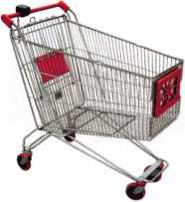

keynotes

Buyer's

**Marketplace**

**Professional Business Products**

**Invoices**

**Checks**

**Business**

**Cards**

**Tags**

**Key Fobs**

**Magnets**

**Labels**

*Call for a free  
brochure and samples*

**1-800-355-6322**

**[www.pbp2000.com](http://www.pbp2000.com)**

0004115

CLAIM CHECK

your firm name here

123 Mam Street

9 YOUR t°wn. state and zip

r- Phone 123*4567

— N°432

IN-STOCK...MORE SAFES

***FREE Freight Program***

***(30 States)***

**AMSEC** FireKing  
Gariall HAYMAN  
MEILINK y/CTOK

**TURO i©**

**WHOLESALE SERVICE**

800**-**848-9790

SAFI CORPORATION

*

CONCEALED SAFES  
for recreational

vehicles and  
water craft

Models Available: SC-1-8”, SC-2-12"

800-253-1267

114 S. Delsea Drive, Suite 3 856-863-1186

Glassboro, NJ 08066 Fax 856-863-1208

ACCEPT CREDIT CARDS!

In your Locksmithing Business,

Storefronts/Offices/Homebased

Businesses

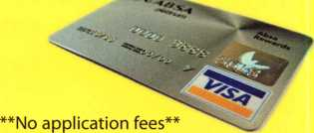

**No Monthly Minimum**

**No Lease Requirements**

**Onsite wireless terminals available**

RETRIEVER PAYMENT SYSTEMS

888-549-6424

Keynotes • February 2006

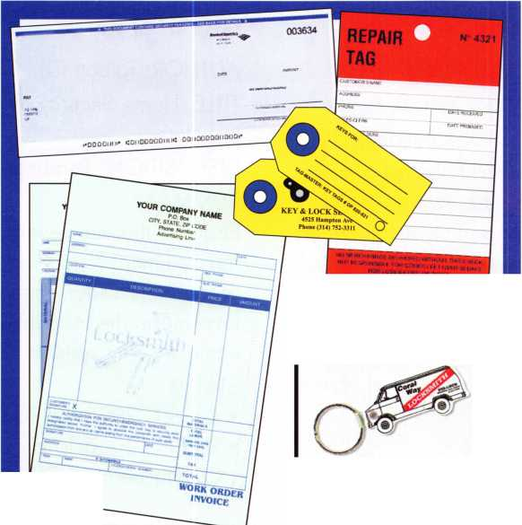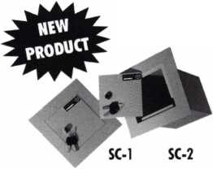

Just ^ a Few

of Our Titles...

Learn About Basic Electricity 29.95

Spacing and Depths, vol 1 19.95

Spacing and Depths, vol 2 19.95

Filing for Dollars 29.95

Antique Padlocks 29.95

VATS Made Simple (Revised) 29.95

Guide to Transponders 79.00

2000 Transponder Update 45.00

Bread & Butter 85.00

Locks and Lockmakers of America 19.95

Learn About Electronic Locking Devices 29.95

The Best of Locksmithing, vol 1 19.95

Logical Lock Diagnostics 29.99

How to Pick Lever Locks 19.95

Fundamentals of Master Keying 55.00

Guide to Electronic Locksmithing 39.95

Security Solutions Locksmith Marketing Program 89.95

The Ultimate Techtips Collection 39.95

...25.00

...27.00

...19.95

...39.95

...14.95

...34.95

...45.00

...29.95

,175.00

.175.00

9.95

...99.00 ,155.00 110.00 ...59.95 1 10.00 1 10.00 ...95.00 .95.00 ...39.95 ...29.95 ...29.95 ...29.95 ...29.95 ...29.95 ..29.95 ...29.95 ...29.95 ...29.95 ...29.95 ...29.95 ...29.95 ...99.00 ...99.00 ...29.95 .115.00 ...69.95 ...14.95 ...27.00 .25.00

...25.00

.595.00

PRP Resource Guide

Locksmithing from Apprentice

to Master

Wafer Lock Reading

Door Lock Encyclopedia

Lock Repair Manual

Interchangeable Core Cylinders

Picking & Impressioning

The Lure of the Lock

High Security Safes, vol 1

High Security Safes, vol 2

Safeman's Guide, vol 13

Safe Deposit Depth and Space Manual

Safe Technician's Reference Manual

Gun Safes

Modern Safe Opening

Dave McOmie on Vault Doors, vol 1, Bank Vaults

Dave McOmie on Vault Doors, vol 2, Fire and Plate Vaults ...

Modern Safe Locks

Drilling Safes

Safe Deposit Box Service

Foreign Car Impressioning Book

Impressioning Ford and GM Side Bar Locks

Automotive Lock Servicing Update #1: GM 10-Cut Locks

Automotive Lock Servicing Update #2: GM 10-Cut Locks

Automotive Lock Servicing Update #3: GM 8-Cut Locks

GM Locks: Perfect for the Beginning Locksmith!

Ford Locks: Pin Tumbler and Ten-Cut Systems

Chrysler Pin Tumbler Locks

Chrysler Double-Bitted Locks

Toyota Split-Tumbler Locks

Basic Door Panel Servicing

Advanced Door Panel Servicing

Motorcycles on CD

The Guide to Motorcycles

Japanese High Security Auto Servicing

Revised GM Steering Column Course

Foreign & Domestic Auto Service

Auto Lock Service

The Sieveking Auto Key Guide & Illustrated Cross Reference

Servicing Interchangeable Cores—Sargent

Servicing interchangeable Cores—Arrow, Best,

Eagle, Falcon, and Lockwood

The Ultimate CCTV Program on CD Rom

**Visit the new-and-improved ALOA Store to view more available titles.  
Place your order online or by phone today!  
[www.aloa.org](http://www.aloa.org) • (214) 819-9733* Please allow 3-4 weeks for delivery.**



The Master Locksmiths  
Association Of New Jersey

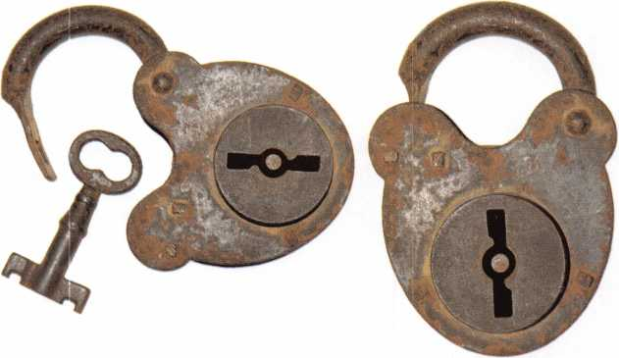

2006

East Coast Regional  
Lock & Security Show

(Classes, Trade Show, and Banquet)

March 16th thru March 19th

Crowne Plaza Meadowlands Hotel  
2 Harmon Drive  
Secaucus, NJ 07094

For more information:

P.O. Box 2441

Morristown, NJ 07962-2441  
Fax 973-538-1588 or visit [www.MLANJ.org](http://www.MLANJ.org)

Alberto, 11 years Machine Operator

SECURITY PRODUCTS

Raymond, 4 years Accounting

Shirley, 23 years Lock Assembly

iry, 8 years stomer Service

[ We represent the 500 employees of CompX Security Products.

Hardworking. Reliable. Dedicated.

And it shows in the products we make.

Is it any surprise that, year after year, you the locksmith community, choose to partner with us?

Made in America does matter to you, and it matters to us. Through our four US facilities, we will continue to provide you with the high quality products you have come to expect from CompX Security Products.

*CbrnfrC*

*G)mjK*

GjnBC GpmftC

*TIMBERLINE*

FORT

NATIONAL

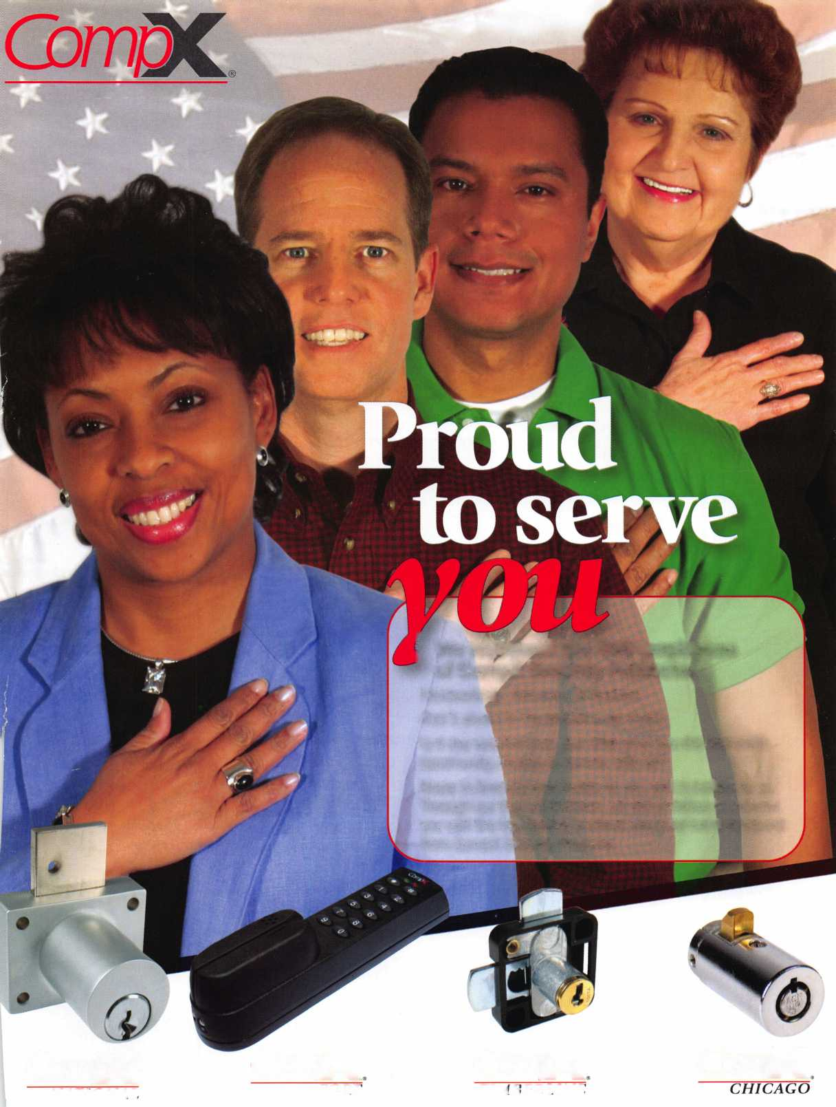

I

I

MEILINK

c/OR SAFES THAT FIT EVERY NEED AND BUDGET, COUNT ON THE TRUSTED BRANDS OF FlREKlNG® SECURITY GROUP. ADESCO® OFFERS SAFES FOR GOVERNMENT, COMMERCIAL AND RESIDENTIAL CUSTOMERS. MEILINK® PROVIDES FIRE- AND BURGLARY-RATED SAFES FOR BANKS, SCHOOLS AND RETAIL ESTABLISHMENTS. AND FlREKlNG FEATURES UL®-RATED FIRE/ IMPACT/BURGLARY RESISTANT SAFES BACKED BY OVER 50 YEARS OF SECURITY EXPERIENCE. PLUS, EACH BRAND COMES WITH EXCLUSIVE 24/7/365 TECHNICAL SUPPORT. SO FIND OUT MORE ABOUT FlREKlNG SECURITY GROUP. YOUR CUSTOMERS TRUST YOU TO RECOMMEND THE BEST. TRUST US TO PROVIDE IT.

#2

**FireKing**

SECURITY GROUP W

[www.fireking.com](http://www.fireking.com)

